

**Fire Safety Management and Evacuation Policy**

North East Futures UTC has been established to change the education, skills and employment paradigm in our IT and Healthcare Science sectors in the North East. It provides the opportunity for young people from all the communities in this region to benefit from its specialist provision.

Local Governors and all the North East Futures staff are committed to a policy of equality and aim to ensure that all students, employees, job applicants, other member of the school community and visitors are treated fairly and with respect.

We aim to give equal access to the high quality educational opportunities we provide and to ensure that everyone feels that they are a valued member of the school community. We seek to create a safe and happy environment where all our students can flourish and where social and cultural diversity are celebrated.

|  |  |
| --- | --- |
| Reviewed by: | Principal |
| Frequency of policy review: | Annually |
| Last Reviewed: | September 2022 |
| By Dan Sydes |  |
| Ratified by Local Board of Governors on: | 05/10/2022 |
| By Derek Marshall |  |
| Next Review Date: | September 2023 |

1

|  |  |  |
| --- | --- | --- |
| **SECTION** | **CONTENT** | **PAGE** |
| **(A)** | **FIRE SAFETY MANAGEMENT** |  |
| **1.0** | INTRODUCTION & SCOPE | 4 |
| **2.0** | DETAILS OF THE PREMISES | 5 |
| **3.0** | DEFINITIONS AND ABBREVIATIONS | 5 |
| **4.0** | PRACTICAL FIRE SAFETY ARRANGEMENTS | 6 |
| **5.0** | PLANNING | 7 |
| **6.0** | ORGANISATION & CONTROL | 9 |
| **7.0** | FIRE DRILLS | 11 |
| **8.0** | INSPECTIONS, TESTING AND MAINTENANCE | 11 |
| **9.0** | TRAINING | 12 |
| **10.0** | INFORMATION DISTRIBUTION | 13 |
| **11.0** | GOOD HOUSEKEEPING AND FIRE PREVENTION | 13 |
| **12.0** | ARRANGEMENTS FOR HIGH RISK AREAS | 14 |
| **13.0** | MONITORING | 15 |
| **14.0** | REVIEW | 15 |
| **(B)** | **EVACUATION POLICY** |  |
| **15.0** | RESPONSIBILITIES | 15 |
| **16.0** | MEANS OF RAISING THE ALARM | 18 |
| **17.0** | ACTION IF FIRE IS DISCOVERED OR SUSPECTED | 18 |
| **18.0** | ACTION ON ACTIVATION OF THE ALARM | 19 |
| **19.0** | FIRE INSTRUCTION NOTICES | 20 |
| **20.0** | EVACUATION PROCEDURE | 20 |
| **21.0** | EVACUATION OF THOSE ESPECIALLY AT RISK | 21 |
| **22.0** | ESCAPE ROUTES TO PLACES OF SAFETY | 22 |
| **23.0** | ASSEMBLY POINTS | 22 |
| **24.0** | FIRE FIGHTING EQUIPMENT | 23 |
| **25.0** | FIRE CONTROL PANEL | 23 |
| **26.0** | CONTINGENCY PLANS | 24 |
| **27.0** | LIAISON WITH EMERGENCY SERVICES | 24 |
| **28.0** | LOCATION OF INFORMATION | 25 |
| **29.0** | COMMUNICATION | 25 |
| **30.0** | APPENDICES | 26 |

**(A) FIRE SAFETY MANAGEMENT**

**1.0 Introduction and Scope**

The purpose of this document is to ensure that:

Everyone within North East Futures UTC knows what to do in the event of a fire; and the school can be quickly and safely evacuated.

1.1 The plan details measures to reduce the risk of fire occurring and actions to take in the event of a fire and takes account of the Fire Risk Assessment for the premises.

1.2 Everyone within North East Futures UTC will comply with the plan and ensure that others under their control e.g. suppliers, contractors and visitors etc. also comply with the requirements of the plan.

1.3 This fire safety management and fire emergency plan applies to all premises that are to any extent under the control of North East Futures UTC**.** Its requirements extend to all persons at those premises including student, staff, visitors and contractors whether permanent or temporary.

1.4 Where premises are jointly occupied or there is shared control of premises with others then the arrangements for fire safety and maintenance will be coordinated, communicated and documented. In these premises the fire safety arrangements and procedures shall apply or local variations agreed by all relevant parties and relevant persons.

1.5 This fire safety management and evacuation policy applies to all on the premises who are employed by any other employer. In this respect other staff will comply with these relevant fire safety arrangements and policy.

1.6 North East Futures UTCwill, so far as is reasonably practicable, and in accordance with legal obligations and standards, in respect of the premises:

* + provide and maintain passive and active fire prevention, protection and measures according to the purpose or use of the building, the numbers of occupants and the activities or processes undertaken therein;

* + provide comprehensible and relevant information to staff and others, through the provision and availability of emergency instructions or fire safety plans and the risks identified by relevant risk assessments;

* + provide a programme of fire safety training to persons appropriately identified in accordance with their role;

* + carry out and keep under review a fire risk assessment to analyse building and process fire risks, the existing preventive and protective measures and to identify areas for improvement;

* + have in place a programme of works to improve or maintain the existing fire safety specifications;

* + identify a sufficient number of persons, whether staff, security or others, to be present at all times the building is occupied with responsibility for initiating the fire evacuation procedure and provide information and assistance to the fire service;

* + where appropriate, to prepare and keep under review risk assessments in relation to the use, storage, handling, disposal and transportation of dangerous substances and ensure that, so far as is reasonable practicable, the risks associated with dangerous substances are reduced or controlled.

1.7 As a minimum, the plan will be reviewed on an annual basis, or:

* + - at any time the plan is found not to be effective e.g. after a fire drill
    - upon significant change to the structure or use of the building

# 2.0 Details of the Premises

North East Futures UTC, Stephenson Square, Stephenson Quarter, Newcastle upon Tyne, NE1 3AS consists of a multi-story main building.

2.1 A plan showing the layout of the premises shall be maintained by the Facilities Management Team and shall include the following information

* Escape routes
* Means of fighting fire
* Location of manual call points and fire alarm panels
* Location of automatic fire fighting systems
* Location of main electrical isolation switch and gas shut-off valve

# 3.0 Definitions and Abbreviations

3.1 The following abbreviations and acronyms may be encountered within this policy.

|  |  |
| --- | --- |
| **BS** | **British Standard** |
| **COSHH** | **Control of Substances Hazardous to Health** |

3.2 The following are definitions for terms that may be encountered on within this policy.

|  |  |
| --- | --- |
| **Assembly Point** | **Designated point for persons who have evacuated the building to assemble** |
| **Authority** | **North East Futures UTC** |
| **Evacuate** | **All persons to leave the building by their nearest exit** |
| **Evac-chair** | **Chair specially designed to aid the evacuation of disabled persons** |
| **Fire Drill** | **A test of the fire evacuation procedures and arrangements** |
| **Premises** | **The School, its buildings and grounds** |

# 4.0 Practical Fire Safety Arrangements

As part of a holistic fire safety management system, in addition to the management action outlined below, considerations of passive and active fire precautions are essential.

4.1 Passive fire precautions are concerned with the physical conditions in premises which are designed to facilitate containment of fire by design, construction and layout, effective communication and safe evacuation. In particular the:

* materials specification, design, construction and inspection of buildings, fire doors and escape routes taking into account the needs of students, staff, visitors, people with disabilities, contractors, the public, etc;

* appropriate safe and secure location of building services e.g. gas and electricity;

* provision of clear fire safety signage for escape routes and final exits in conformity with the Health and Safety (Safety Signs and Signals) Regulations 1996 and Disability Discrimination Act 1995;

* provision of prominently located fire action notices (e.g. by fire alarm manual break glass points) to inform people of the action to be taken in the event of fire; and

* Education and training of staff in fire safety arrangements, in particular evacuation procedures and drills.

4.2 Active fire precautions are those features of the fire safety management system that detect and operate in the event of a fire, including fire alarm systems, emergency lighting systems and fire fighting equipment. In particular:

* the installation, maintenance, inspection and weekly testing of fire alarms;
* the appropriate design, location, operation, monthly inspection and annual testing of adequate (emergency) lighting systems for fire escape routes;
* The provision, use, appropriate type and location, and annual maintenance of portable fire extinguishers.

4.3 The fire safety arrangements will be based on HSG 65 *Successful Health and Safety*

*Management* and the Fire Safety Management Plan Strategy (see Appendix 1). The main strands of the strategy involve: -

* Effective planning, organisation, control, monitoring and review of protective and preventative measures
* Fire safety risk assessments and building audits
* Fire safety systems and maintenance
* Fire warden and staff training
* Fire evacuation drills
* Building design, alterations and commissioning

# 5.0 Planning

5.1 Fire risk assessments are a requirement of the Regulatory Reform (Fire Safety) Order and are a structured approach to determining the risk of fire occurring in a premises or from a work activity, and identifying the precautions necessary to eliminate, reduce or manage the risk. The outcome of the risk assessment must be incorporated in the fire emergency plan (see Section 7).

5.2 Fire Risk Assessments must be carried out and reviewed the start of each term or when there is any building alteration or change of occupation and use of the premises, or following a fire incident/emergency.

5.3 The risk evaluation and appropriate control measures to be taken into account will include those practical fire safety arrangements outlined above. The methodology adopted will be:

**High Risk** = Work to be completed within 4 to 8 weeks

**Medium Risk** = Work to be completed within 6 months **Low Risk** = Work to be completed within 1 year

5.4 Risk assessments must take into account those who could be affected, e.g. numbers involved, their location, physical and mental capabilities and employees of organisations with whom a workplace is shared. The significant findings of the fire safety risk assessment will be made known to all other responsible persons as appropriate.

5.5 Where appropriate, an individual Personal Emergency Evacuation Plan (PEEP) must be developed for staff, pupils, visitors or service users who have known disabilities or medical conditions that will impact on their ability to evacuate the particular premises.

5.6 Maintenance of fire safety systems will be managed by the Facilities Manager and where necessary external contractors will be commissioned to carry out the maintenance on fire systems and equipment in compliance with the Regulatory Reform (Fire Safety) Order 2005 and Approved Codes of Practice and other associated legislation. Fire Maintenance Contractors will be fully inducted for safe work practices and are fully qualified to carry out maintenance on fire safety systems and will include: -

* Fire detection and warning system
* Emergency lighting
* Fire fighting facilities
* Emergency routes and exits
* Fire safety signs and notices
* Portable electrical appliances (PAT, yearly)
* Premises installation testing (5 yearly)

* 1. The fire safety maintenance programme will follow the guidelines suggested in HM Government Fire Safety Risk Assessment guidance and can be found in Appendix 2.

* 1. Fire Warden and staff training are provided through the school who can arrange a number of courses annually. The course is delivered by a competent person. It is the responsibility of all Fire Wardens to attend one refresher training annually.

* 1. Fire evacuation exercises will be carried out twice per year within the premises. The purpose of these exercises is to educate premises occupants in the correct manner of evacuating a building in the event of an emergency situation and to meet legal obligations. All evacuations will be conducted by the Fire Wardens under the guidance of a Fire Safety Officer. Pre and post de-briefing sessions will accompany each evacuation drill.

* 1. Provisions will be made for the safe evacuation of disabled people. Emergency refuge call points are located in the stairwells and are activated by the alarm system.

* 1. Fire evacuation of a building will be in accordance with established procedures in the fire evacuation plan (Section 7). In the event of a fire alarm outside of normal business hours, building occupants are to evacuate the building and assemble at the Assembly Point at the walkway in front of the building or at the Secondary Assembly Point in front of the Crowne Plaza Hotel, if instructed by the Responsible Person. All staff, visitors and contractors will be made aware of the fire procedures.

* 1. All building design work shall comply with relevant codes and standards. New building works and refurbishment projects that include fire safety equipment and systems will be sanctioned prior to any work being carried out by the Principal and Health and Safety officer.

* 1. Testing of building passive and active fire evacuation systems are to be conducted by the Leadership Team at agreed appropriate times during normal hours and in line with the installation requirements and current British or European test standards. All fire wardens will be trained in the use of the evacuation system.

* 1. Fire Wardens will report any faults or problems to the Fire Safety Officer / Health and Safety Manager.

* 1. A fire safety log book will be kept to record the details of all tests on passive and active preventative and protective measures, as well as training and fire drills.

* 1. To help make it manageable throughout the year an annual management cycle reflecting these elements.

|  |
| --- |
| **Stage One**    **Review Policy and Organise Sept-Nov** |
| **Stage Two**    **Plan and Implement Dec-Feb** |
| **Stage Three**    **Monitor/Measure Performance and Report March-July** |

# 6 Organisation and Control

6.1 Specific named individual responsibility for overall responsibility for Fire Safety, maintenance, Emergency Plans and Staff Training can be found in Appendix 5 & 6

6.2 The Health and Safety Officer and in some cases the Facilities Management Team, under the direction of the Principal will:

* Ensure that this Policy and/or any departmental fire safety policies/codes of practice that complement this Policy are in place, properly implemented and reviewed.

* ensure that a Responsible Person is appointed for the premises to oversee and implement fire safety arrangements, and ensure that they are competent and appropriately trained to undertake their duties;

* ensure that arrangements are in place for the completion of fire risk assessments, including, where appropriate, technical surveys in respect of fire protection;

* ensure, in conjunction with the outcome of the fire risk assessment that the optimum number and type of fire extinguishers are installed in appropriate locations;

* ensure that fire alarm and detection systems, emergency lighting and fire extinguishers are appropriately located and properly maintained;

* arrange for the emergency plan to be issued to employees, visitors, etc. to inform them what to do in the event of fire, particularly safe evacuation;

* arrange for a competent responsible person who is the Health & Safety Manager for the premises to coordinate and implement fire safety arrangements;

* ensure that if there is any doubt about the provision of new or replacement fire extinguishers a specialist BAFE certified company assess the need and that this is then acted upon;

* ensure that staff are appropriately trained in fire safety procedures to reflect the requirements of the fire risk assessment;

* ensure that a copy of the current fire risk assessment for the premises is readily accessible in the staff shared area on the network and its provisions complied with;

* ensure that fire risk assessments are reviewed at least annually or whenever there is any building alteration, change of occupation or use of the premises or following an incident involving fire;

* ensure that effective arrangements are in place for contacting the emergency services;

* ensure that the Fire and Rescue Service are aware of any significant hazards associated with the premises e.g. oxygen cylinders, storage of petrol, etc. all this information is to be held in the Emergency Services Pack/Fire File;

* confirm that the termly premises fire safety inspections address fire safety arrangements; and

* Liaise with the local trade union safety representative, where appointed, on all aspects of the above arrangements.

* 1. Senior Leadership / Heads of Department with responsibility for premises or parts of premises or departments will ensure that risk assessments are carried out for all their workplaces, classrooms, specialist areas, and for specific activities;

* 1. The Competent Persons must instruct/oversee relevant staff to:

* assist and support with the preparation and review each term the fire safety risk assessments;

* ensure compliance with the outcomes of the fire risk assessment and that the necessary control measures are implemented;

* prepare and review the emergency plan and issue to all staff;

* ensure information on fire safety arrangements is available to service users and visitors;

* Ensure all staff and, where appropriate, contractors are instructed in the emergency plan;

* arrange and review fire drills termly;

* Specify and rehearse the arrangements for assisting visitors, disabled people or those with temporary physical impairments to safely evacuate the premises. Where appropriate, a PEEP must be developed;

* ensure Fire Alarms are regularly tested at the recommended frequency in accordance with manufacturers and British standards - weekly;

monitor that fire alarm systems, detection devices, emergency lighting and fire extinguishers are appropriately and regularly maintained;

* keep the fire log book up to date;

* ensure that fire action notices and fire signage are appropriate and kept up to date in accordance with the local fire authority and fire regulations;

* ensure all escape routes are kept clear of obstructions and that access to fire extinguishers and fire alarms is not impeded;

* ensure that the annual testing of portable electrical equipment (PAT) and periodic testing (5 yearly) of the fixed electrical installations has been carried out, and

* Ensure that each term fire safety inspections of the premises are carried out and that these address fire safety arrangements.

6.5 Employees must:

* ensure they are familiar with the emergency plan for their workplace and co–operate by participating in fire evacuation/drill procedures and by observing practical fire safety arrangements;

* know, and co-operate with, the responsible person for their workplace;

* report to their head of department, Senior Leadership Team, or line manager any concerns about fire safety;

* be familiar with all escape routes;

* Ensure all visitors, students or individuals they are responsible for are safely escorted from the building in the event of a fire evacuation and that they enforce all procedures.

* not wedge fire doors open, nor block or obstruct them;

* be aware of the action to be taken on discovering a fire, hearing a fire alarm, for raising the alarm and evacuating the building in a safe manor;

* promptly evacuate the premises, in accordance with the emergency plan, to the evacuation assembly point without putting themselves and others at risk, and NOT attempt to extinguish a fire unless to aid escape or they have been specifically trained; and

* Comply with the No Smoking legislation.

## 7.0 Fire Drills

7.1 Drills will be arranged by the Responsible Person in liaison with the Facilities Management Team who will arrange for the system to be taken off line. These will be carried out once per school term as a minimum.

7.2 Records of fire drills will be maintained, where appropriate SLT shall instigate changes to the fire plan and/or procedures based on lessons learnt from the fire drills.

## 8.0 Inspections, Testing and Maintenance

8.1 The Facilities Management Team will undertake checks to ensure fire exits are unobstructed, fire extinguishers are in place and fire notices and signs are in place and in good condition. The check will be recorded within the Planned Preventive Maintenance (PPM) records.

8.2 The systems and equipment installed in the school are maintained by Facilities Management contractors appointed by North East Futures UTC to reduce the risk of fire (e.g. electrical testing) and to ensure fire protection measures (e.g. fire alarm system) are in good working order.

8.3 The tasks are programmed as part of the Annual Health & Safety Plan and carried out by competent persons; records of completion of the tasks are maintained and held in the Fire management spreadsheet.

8.4 Systems/installations include:

* Electrical installation tested in accordance with BS 7671
* Portable electrical appliances tested in accordance with the Electricity at Work Act
* Fire alarms test and maintained in accordance with BS 5839
* Fire extinguishers and sprinkler systems maintained in accordance with BS 5306
* Emergency lighting tested and maintained in accordance with BS 5266

8.5 The following checks are also carried out as part of the Facilities Management Team duties on a weekly basis:

* All fire resisting doors function correctly and are not missing any cold smoke seals (if fitted)
* All door furniture and escape mechanisms i.e. panic bolts and fail safe locks etc. are functioning correctly
* All notices and signs are correctly positioned and are up to date
* All routes are clear of obstruction and fire exits are easily opened

8.6 In the event of any of the fire protection measures being out of service e.g. fire alarm, the Facilities Management Team will advise the Business Liaison Manager and the Principal. They may wish to seek advice from the Tyne Coast Academy Trust (TCAT) and all parties will agree what additional fire safety measures are to be undertaken e.g. fire patrols, or restrictions on activities to reduce fire risk.

## 9.0 Training

9.1 All persons who work on a long term basis in North East Futures UTC will be given fire safety training, training will be provided by the employer; the training will include:

* The action to take on discovering a fire
* How to raise the alarm and what happens then
* The action to take on hearing the fire alarm

The procedure for alerting students, members of the public and visitors, including directing them to exits

* The evacuation procedure and arrangements
* The location and, where appropriate, the use of fire fighting equipment
* The location of the escape routes
* How to open escape doors and the importance of keeping fire doors closed
* The reason for not using lifts
* The importance of general fire safety and good housekeeping

* 1. All staff are aware of the fire evacuation procedure, and visitors are instructed to leave the building by the nearest exit.

* 1. Those with specific responsibilities under this plan will be trained on carrying out those duties.

* 1. Staff specifically trained in Fire Safety are listed in Appendix 6

## 10.0 Information Distribution

10.1 Detail the method(s) of informing personnel (incl. visitors / contractors) of escape routes. This should include the following: -

* Induction training will be given to staff and students upon their first day in the building. The training will include; Emergency exit / route signage, Appendix 7, what to do if they discover a fire (Section 17), what they should do if they hear the fire alarm (Section 18).
* Annual training will be given to all staff and students to ensure they are fully aware of what do in the event of a fire or the need to evacuate the building.
* Fire action notices are to be displayed on the entrance/exit point of the building to allow users of the building to familiarise themselves with other possible routes from the area they are entering.
* The Emergency Plan drawing clearly showing multiple alternative routes informing personnel of an alternative escape route should the main one be blocked or inaccessible.
* This Emergency Plan is to be readily available to all on the school network for access in school and over the internet for remote access off site.

## 11.0 Good Housekeeping and Fire Prevention

11.1 The risk of fire can be significantly reduced by good housekeeping and observing basic fire prevention measures.

11.2 Users of the premises can assist with this control measure by ensuring that their work area is tidy and that they adhere to the fire procedures in place to keep the risk of fire to a minimum. Housekeeping measures include:

* Keeping amounts of paper and combustible material/waste to a minimum and ensuring it is disposed of at the end of each working day
* Preventing and/or reporting to the Facilities Management Team accumulations of rubbish, waste paper and other material in and around the premises, especially in circulation areas and escape routes

Flammable materials and liquids should be kept in the designated place or storage cabinet and the specified quantities should not be exceeded. They should be clearly identified as flammable. A register of such substances must be maintained. Using only limited amounts of flammable liquids and gases in accordance with COSHH requirements. Use of water based products for certain operations should be considered. A COSHH Assessment and/or Risk Assessment should be in place for each chemical and its use.

* Not storing combustible material such as paper next to electrical appliances/systems and other heat sources
* Ensuring that all fire routes and exits are kept clear at all times
* Fire doors should be kept shut unless the doors are connected to an approved electrically operated hold open device. Such doors must not be wedged open
* All doors and windows should be closed when the premises are left unoccupied
* Plugs and electrical sockets should not be overloaded and correct fuses should be fitted
* No unauthorised personal equipment such as kettles, radios, heaters, etc. to be used
* Turn off electrical equipment when not in use and at the end of each working day unless it is designed to be connected permanently or switched on constantly
* Machinery and electrical office equipment should be well ventilated, not obstructed, and cleaned regularly
* Control of external storage/increased vigilance to minimise the risk of arson
* Reporting of defective fire provisions e.g. fire doors, alarms, extinguishers, emergency lighting
* If contractors are working in the premises, those supervising the work should ensure that fire precautions are maintained.

## 12.0 Arrangements for High Risk Areas

12.1 As most fires in kitchens involve oils or fats used during cooking, attention will be given to cleanliness to prevent the build-up of fat in and around equipment and ventilation systems. As Sodexo provide the catering service the Business Liaison Manager will work with them to ensure the systems and practices meet the needs of the school.

12.2 Sodexo will ensure that any staff who use cooking equipment will receive instruction in the use and everyday maintenance (e.g. cleaning) of all catering equipment prior to use.

12.3 Sodexo will ensure that all kitchen staff are given training and instruction on what to do in the event of a fire in the kitchen this will include:

* Always give alarm of fire and ensure the monitoring service have contacted the emergency services – Do not assume you can put the fire out or that the fire has been extinguished - Call the fire service for them to confirm
* Turn off the gas or electrical supply to the apparatus if safe to do so
* Smother the fire by closing the cover or by using a fire blanket if safe to do so
* Use an appropriate fire extinguisher if safe to do so
* Not to use water on fires involving oils or fat
* If the fire is inside an oven, do not open the oven door
* If there is fat burning on the floor, smother it with a fire blanket or foam.

12.4 To reduce the risk of fires Sodexo staff will:

* Not to hang towels or aprons where it is possible for them to come into contact with any source of ignition such as cookers and other heated surfaces

Not to dry or air cloths and aprons over oven doors, on boilers or on lines over cookers or other sources of ignition.

* 1. Sodexo staff will make a final inspection each day before leaving to ensure that all equipment is turned off (except equipment normally left running, such as refrigerators and freezers).

* 1. Staff will identify processes, machines or power that must be shut down:
* Staff responsible for ensuring any hot work equipment is turned off
* Science labs
* Technology departments
* Kitchens

All of this information for isolation cut off points for service is presently held in site documentation and is to be added to this plan.

12.7 Specialist rooms/areas around the building are high risk due to the nature of the room and its purpose –

* Boiler room/plant room • Chemical storage areas in Science Prep Room/Labs, cleaning stores, Facilities Management store, technology store
* Fuel storage
* Technology department due to the combustible material within this area.
* Science Lab area due to chemicals and gas supply.
* Art department due to combustible material within this area.
* Kitchens

All of this information for isolation cut off points for service is presently held in Site documentation and is to be added to this plan. This is to be placed in Appendix 8.

## 13.0 Monitoring

13.1 The following Key Performance Indicators (KPI's) will be used to monitor the effectiveness of the Fire Safety Management Plan: -

* Number of fires recorded annually / number of fire related incidents.
* Achieving set schedules and time frames (evacuation drills and building audits).
* Measuring the number of Fire Service call outs against cause.
* Number and nature of enforcement, alterations or prohibition notices from statutory authorities.
* Termly premises inspection and meetings to ensure actions and progress are made. Some inspection may be required more frequently.
* Annual audit of all fire systems.

## 14.0 Review

14.1 Annual audit of all fire systems to ascertain compliance with not only statutory provisions but with this Fire Safety Management Plan.

14.2 Active reviews will take place termly prior to any likely accident or event

14.3 Reactive reviews will take place following a fire safety event occurring

14.4 A review will also be undertaken following a fire, changes to the premises construction and facilities, new procedures, new equipment, new materials and changes in staff numbers and roles

# (B) EVACUATION POLICY

## 15.0 Responsibilities

15.1 When allocating responsibilities consideration must be given to ensuring adequate cover for holidays, sick leave etc.

15.2 To ensure fire evacuations are carried out in a safe and coordinated way, the Responsible Person(s) have specific responsibilities.

15.3 The Responsible Person(s) shall be issued with a yellow Hi-visibility Jacket/vest to be worn in case of evacuation. Responsible Person’s responsibilities include:

* Receive information from Facilities Management Team regarding the cause of the alarm
* Direct contact with monitoring service/emergency services and take overall control of the situation with the assistance of the Facilities Management Team
* Be the coordinator of all evacuation control measures

* 1. Designated Responsible Staff for these premises are listed below:

|  |  |
| --- | --- |
| **Responsible Person(s)** | |
| **The Responsible Person will direct evacuation procedures in the event of the alarm being raised and ONLY the Responsible Person will decide when it is safe to re-enter the building and inform the Facilities Team to switch off the alarm.** | |
| **Responsible Person: Sarah Galvayne (Health and Safety co-ordinator, Senior Science Technician**)  **If off site :Sarah Hughes (Business Liaison Manager) If off site: Dan Sydes (Principal)** | |
| **Designated SLT – Responsible Person** | **Dan Sydes (Principal)**  **Sarah Galvayne (H&S Co-ordinator/Science Technician)** |
| **Responsible Person – Out of Hours** | **Facilities Management Contracted Site**  **Manager – Robertsons FM**  **Jack Cook** |
| **The Designated Person(s) will be in contact by radio to check the effectiveness and safety of the overall evacuation.** | **It is the responsibility of all persons above, named as cover for absent staff, to be aware of when the person they are covering is on / off site.** |
| **Protection Officer** | **Jack Cook** |

|  |  |
| --- | --- |
| **PEEP Coordinator** | **Helyn Bulman** |
| **Register Coordinator** | **Rebecca Oates / Jess Murphy, Charlotte Murray** |

* 1. The Fire Marshals shall be issued with yellow Hi-visibility jacket/vests to be worn in case of an evacuation.

* 1. **FIRE MARSHALS (Named Staff)** responsibilities include:
* In case of evacuation, directing employees, building users and their visitors to leave the building by the nearest available fire exit
* Help those not familiar with the evacuation procedure or those that may be especially at risk
* Ensure year groups are assembled efficiently in the evacuation zone with support from other teachers/staff
* If safe to do so sweeping their area to ensure it is clear
* Receive information from other staff that the building is clear of people
* Remain in contact with the Responsible Person by radio, or by sending a runner (if it is safe to do so)
* The signing in/out record of visitors (InVentry app to be installed on mobile and paper registers printed), and if it is safe to do so, ensuring that these are taken in the event of an evacuation to be used as a register. This will be the responsibility of the Receptionist as part of their daily duties.
* Arranging Fire Alarm tests and Fire Drills
* Co-ordinating fire precautions on site
* Liaising with the Responsible Person and the Emergency Services
* On confirmation of an incident ensure the monitoring service/emergency services have been called

15.7 **FIRE WARDENS (Other Staff)** responsibilities include:

* Assisting people to evacuate the building
* Help those not familiar with the evacuation procedure or those that may be especially at risk
* If safe to do so, sweeping their area to ensure it is clear
* Advising anybody trying to (re)enter the building of the dangers and instruct them not to enter
* Notifying the fire marshal of anybody who has entered the building
* Reporting to the Fire Marshall that persons have left their designated area
* Check toilets are unoccupied (including accessible ones)

* 1. The Fire Marshalls for these premises are:

|  |  |  |
| --- | --- | --- |
|  | **Fire Marshall** | **Fire Marshall Backup** |
| **NORTH FLOOR 0** | Jen Lorimer **®** | Charlotte Murray |
| **SOUTH FLOOR 0** | John Pattison | Jo Harrison **®** |
|  |  |  |
| **NORTH FLOOR 1** | Charlotte Murray | **®**  Sarah Hughes |
| **SOUTH FLOOR 1** | Jo Harrison **®** | Charlotte Murray |
|  |  |  |
| **NORTH FLOOR 2** | Sarah Hughes **®** | Lucy Arbon |
| **SOUTH FLOOR 2** | Lucy Arbon | Andrew Noakes |
|  |  |  |
| **NORTH FLOOR 3** | Andrew Noakes | Tom Sunderland |
| **SOUTH FLOOR 3** | Dom Hall | Tom Sunderland |
|  |  |  |
| **NORTH FLOOR 4** | Mark Woods **®** | Andrew Noakes |
|  |  |  |
| **MUGA / ROOF – SOUTH FLOOR 4** | H&F staff or duty staff – otherwise locked at all times | H&F staff or duty staff – otherwise locked at all times |
|  |  |  |
| **MAIN OFFICE / RECEPTION / BUSINESS PARTNERS LOUNGE** | Rebecca Oates | Charlotte Murray |
|  |  |  |
| **OUTSIDE YARD** | Duty Staff | Duty Staff |
|  |  |  |
| **PLANT ROOM** | Locked at all times | If open Jack Cook |
|  |  |  |
| **LEASED SPACES** | Responsibility will be assigned to their staff to sweep their rooms |  |
|  |  |  |
| **CATERING KITCHENS** | Catering staff | Leanne Golightly |
| **Contact Numbers** |  |  |
| **Facilities Manager**  **Principal**  **Health &Safety Manager**  **Business Liaison Manager** | Jack Cook - 07392285753  Dan Sydes – 07709632242  Sarah Galvayne - 07903727417  Sarah Hughes - 07825776848 |  |
|  |  |  |
|  |  |  |

* 1. **Protection Officers responsibilities:**
* Are to position themselves at their allocated area of responsibility to ensure people do not reenter the building
* Are to position themselves at the telephone located next to the fire panel at the rear of the building, and pass information to the Fire Service of anybody in the refuge areas
* Are to coordinate those with PEEP’s

15.10 **All Staff**

In case of evacuation, immediately directing employees, building users and their visitors to leave the building by the nearest available fire exit and taken to correct assembly point.

## 16.0 Means of Raising Alarm

16.1 North East Futures UTC is fitted with an automatic fire detection system. In the event of one of the detectors being activated the alarm will sound throughout the building.

16.2 Manual break-glass call points are also installed adjacent to all exit doors from the building. Activation of any of these call points will sound the alarm throughout the building.

16.3 In the event of the alarm being raised, a sounder will ring continuously, unless silenced from the main control panel by the Facilities Management Team.

16.4 The main control panel for the fire alarm system is located at the rear entrance to the building with a secondary panel in reception.

## 17.0 Action if Fire is Discovered or Suspected

* Any person suspecting or discovering a fire shall immediately operate the nearest fire alarm call point, unless the fire alarm has already been activated.

* Immediately evacuate the building by the nearest available exit – without stopping to collect personal possessions.

* Proceed to the assembly point and report any relevant details to the Responsible Person, such as location of suspected fire/extent of it.

* No attempt should be made to fight the fire unless it is to aid an escape.

* The procedure below will be implemented accordingly.

* Where appropriate check toilets and close windows and doors on the way out.

* If an individual has responsibilities for assisting persons with Personal Emergency Evacuation Plans (PEEP's) they will respond as required following the actions as identified in the PEEP.

* Ensure visitors and pupils are escorted from the building to the assembly point and registered, if any pupils known to be in the building are not registered report immediately to the Responsible Person.

* Do pass any information to the fire wardens at the assembly point.

* Close any doors en-route without delaying your escape.

* You must remain at the assembly point ensuring students are organised in registration groups and are acting in a responsible manner.

* Return to the building only when authorised to do so by the Responsible Person.

## 18.0 ACTION ON ACTIVATION OF THE ALARM

18.1 The premises are fitted with an automatic fire detection system which automatically contacts a monitoring station that is staffed 24 hours a day, 365 days a year.

18.2 If it is safe to do so the Facilities Management Team should carry out initial investigations into the alarm activation, to avoid the unnecessary call out of the fire service if it is a false alarm and liaise with the fire service/monitoring service.

18.3 If the facilities management identify an actual fire, between the hours 0800-1800 the health and safety co-ordinator will be notified over radio and will then immediately call **999.** Between the hours of 1800-0800, the monitoring station will call the Facilities Manager within 60 seconds of the alarm activation to determine whether it is a potential fire or a false alarm.

18.4 In situations where the alarm sounds and it is suspected that there is a real incident, the Health and safety Co-ordinator will call **999** to confirm that the alarm has interfaced and with initial investigations, a real fire is suspected. This will be done irrespective of the fact that an automatic system has been installed.

18.5 If, five minutes after the activation of the alarm, the emergency services have not arrived or there is no visible or audible sign of them, the Health and Safety co-ordinator will call **999** via the nearest available telephone.

18.6 In the event of a fire alarm sounding the Facilities Management Team will be contacted by the monitoring service between the hours 18.00-0800 to verify there is a fire and will contact emergency services if necessary. If the alarm sounds between the hours of 0800-1800 then the fire service will need to be contacted directly to confirm a fire. If someone discovers a fire onsite and the alarm has not been triggered they will call **999** using the first available telephone after reaching a place of safety.

### 19.0 Fire Instruction Notices

19.1 Fire Instruction Notices are displayed in conspicuous positions throughout the school and highlight the action to be taken by staff and others upon discovering a fire and on hearing a fire warning.

19.2 As part of the maintenance programme, the Facilities Team will carry out inspections to ensure that that Fire and Emergency Instruction Notices are maintained in good condition and that the information contained on them is up to date.

### 20.0 Evacuation Procedure

20.1 On hearing the Fire Alarm all persons shall:

* Close all manual windows and doors – Only if it is safe to do so
* Evacuate the building using the nearest available exit – Do not stop or return to collect personal possessions
* Ensure any visitors evacuate the building with you
* Not use lifts
* No attempt should be made to fight the fire unless it is to aid escape.
* Go to the Assembly Point
* Pass any information to the fire wardens/responsible person at the assembly point
* Remain at the Assembly Point, ensuring students are organised in groups and are acting in a responsible manor, until instructed otherwise by the Responsible Person or the Fire Service.
* Do not re-enter the building until told it is safe to do so by the Responsible Person or Fire Service.

* 1. The teacher or other adult responsible for students in a classroom or other area of the building shall supervise the safe exit of all students under their control.

* 1. The teacher or other adult responsible shall also assist those especially at risk e.g. disabled persons as have been appointed in the PEEPS.

* 1. The Protection Officer will ensure the fire evacuation plan is available for the Fire Service

* 1. A visitor log can be accessed through the InVentry system App which will be installed on all Fire Wardens mobile phones. A print out will also be taken to the assembly point where all visitors will be checked against and accounted for by a member of the Administration team, who will inform the fire service whether or not all persons are accounted for.

* 1. No one is to re-enter the school premises until it has been checked and declared safe by the fire service.

### 21.0 Evacuation of Those Especially at Risk

A disabled refuge call point is located on each level in the stairwells. In the event of a fire, disabled persons should communicate with the protection officer via the call point and remain at the refuge area until instructed by the fire service.

21.1 The following staff are Evac – Chair Operators:

Lucy Arbon

Helyn Bulman

Sarah Galvayne Rebecca Oates

Sarah Hughes

Charlotte Murray

Karen Nixon Pieter Vermaas

Andrew Noakes

John Pattison Mark Woods

Evac - Chair Operators duties are:

* Only if necessary, evac chair operators should follow procedure to evacuate disabled persons, but only if it is safe to do so

21.2 Examples of people who may be especially at risk include, people who have:

* Impaired vision/hearing
* Impaired mobility e.g. Wheelchair bound, difficulty walking or unable to walk unaided • Learning difficulties
* Have other special needs that may increase the risk of harm in the event of an emergency.

* 1. The Responsible Person shall liaise with staff to ensure they know which members of staff, students or others are particularly at risk in the event of a fire/evacuation.

* 1. These members of staff and students may require special consideration and help if evacuation is necessary.

* 1. Arrangements for evacuation of those identified as being especially at risk must be included in fire/emergency drills to ensure arrangements are effective.

* 1. Staff shall be made aware during their induction that they are responsible for ensuring the evacuation needs of any visitors they receive that would be especially at risk.

#### 21.7 Refuges

A refuge is an area that is separated from the fire by a fire-resisting construction, has access via a safe route to a final fire exit and is clearly marked up with appropriate signage. Refuges are relatively safe waiting areas which can be used for short periods. They are not areas where disabled people should be left alone indefinitely, until rescued by the fire brigade or until the fire is extinguished.

This method has been designed into North East Futures UTC as a number of refuge points are available with an intercom system which allows the user to communicate with the operator of the alarm panel. During the sweep of the premises by the Fire Wardens any person using a refuge point would be discovered by a Fire Warden. In this event the Fire Warden would if necessary assist with movement of the individual from the ‘fire compartment’ they are presently in, to another ‘fire compartment’ away from danger.

#### 21.8 Visitors and Contractors

Any visitors to the premises have to be signed in to the visitors log on the InVentry system at the school reception. Any visitors to the main reception who have permission to enter the building will be issued a visitors pass in line with the Lanyard Policy. Supervised visitors who have a black lanyard must be escorted at all times by a member of staff who is responsible for the visitor.

Any contractors entering the premises will sign into the visitor log on the InVentry system at reception. If the contractor is a frequent visitor then they will have Enhanced CRB checks completed and under go the induction process. Infrequent contractors will be escorted at all times whilst on the premises in line with Safeguarding measures in place. All contractors will be given information about the site's fire evacuation procedures and what they should do in the event of a fire evacuation.

### 22.0 Escape Routes to Places of Safety

22.1 The escape routes to a place of safety are generally via the main corridors and stairwells to the fire exits, all routes are marked with signs showing the nearest emergency exit, all fire exit routes are also fitted with emergency lighting**.** All areas of the building are covered by multiple escape routes to allow escape if the main route is obstructed due to the cause of the evacuation.

22.2 The following locations have emergency exits direct to a place of safety.

* Science demo lab
* Art Classroom
* The front and rear entrance to the school.

For ease of reference included in this documentation are fire strategy diagrams for each floor showing:

* escape routes
* fire containment
* fire fighting equipment locations
* location of designated 'Safe Refuges'
* types and location of emergency exit signs
* locations of manual break glass points • location of gas cut off valves
* location of electrical isolation boards
* emergency lighting

### 23.0 Assembly Points

23.1 On leaving the premises all persons shall go to the designated assembly point (See locations of assembly point below).

23.2 The specified assembly point must be used; this has been selected to be a safe distance from a potential fire and clear of the routes used by the emergency services.

23.3 The assembly point is:

Assembly Area – Staff, Students and Visitors – Out the front of the building at the entrance to the UTC walkway.

Those who exit from the rear of the UTC will follow the walkway up past the Boilershop and left around to the hotel then register at the space in front of the UTC entrance walkway at the evacuation point. *This is not ideal but is the best possible temporary solution until the surrounding area has been developed and the evacuation point can be re-designated.*

Update Sept 2019 : After review of the most recent fire drill ,assembly points have been allocated per tutor group to ensure the safe and efficient registration of all students and staff. Please see **appendix 10** for allocated points.

Update Sept 2020: Covid -19 Evac plan will be used and in line with COVID RA , this will be reviewed periodically and when pandemic rules relax new muster points will be allocated to cater for new year group students.

Once evacuated everyone must relocate to the evacuation point where registers will be taken.

23.4 A secondary assembly point is located in front of the Crowne Plaza Hotel, this assembly point will only be used if the primary assembly point becomes unsafe due to location of fire/smoke. The relocation of all students and staff to the secondary assembly point shall be determined by the responsible person/fire officer.

### 24.0 Fire Fighting Equipment

24.1 The school is equipped with fire extinguishers; these are of the following types:

* Carbon Dioxide
* Water
* Dry Powder
* Wet Chemical

Fire Extinguisher locations are specified on the fire strategy plans in the Appendices. These are used to aid escape only do not attempt to fight the fire.

24.2 Fire blankets are also provided at the following locations:

* Dining kitchen Area
* Staff Room Kitchen Area
* Science Labs

Fire Fighting equipment is positioned in accordance with Galliford Try Fire Strategy Plan, which has been provided, building control, building regulations, fire safety regulation, and appointed BAFE certified contractor and the local fire authority. Refer to Galliford Try documentation and Appendix 11.

### 25.0 Fire Control Panel

Lee Brebner (Facilities Manager), Dan Sydes (Principal) and Sarah Hughes (Business Liaison Manager) are the only trained personnel who are able to operate the fire panel and give the all clear.

### 26.0 Contingency Plans

Contingency plans should be in place for when life safety systems such as evacuation lifts, firedetection and warning systems, sprinklers or smoke control systems, emergency lighting or building power system are out of order.

26.1 As part of our emergency plan staff and other responsible people need to be aware that students or members of the public may want to try and re-enter the building such as:

* unaccompanied children;
* people with personal belongings (especially valuables) still in the building;
* people wishing to re-join friends;
* getting people away from the building (e.g. to transport);
* inclement weather.

Members of staff need to prevent anyone re-entering the building and putting themselves or others at risk.

#### 26.2 Re-entering the Building

No one is allowed to re-enter the building unless the person with overall control as given permission, this may also be the Senior Fire Service Officer if the emergency services have been called.

#### 26.3 Contingencies if not Re-entering the Building

If re-entering the building is not an option or only parts of the building cannot be occupied then parents/careers will need to be contacted and students will be sent home. Transport for some students may also need to be arranged.

### 27.0 Liaison with the Emergency Services

27.1 On discovery of a fire the Facilities Manager will contact the monitoring service who should have received a signal from the school to alert them of a fire. Once the Site Team have confirmed Fire & Rescue Services are required the monitoring service will contact emergency services who will dispatch the appropriate services.

27.2 After evacuating the building and ensuring the evacuation is complete the Facilities Manager, shall ensure that there is sufficient and visible access for emergency service vehicles (including potential need for police/medic access).

27.3 When the emergency services arrive, the Health & Safety Officer will liaise with the emergency services. In the absence of the H&S Officer the Principal or Assistant Principal will take responsibility. They will provide:

* Type of emergency (verbal)
* Location of fire/incident (verbal)
* Names and last-known locations of anybody not accounted for • Persons in Refuge Areas.
* Site Layout plans and locations (Pack)

− Main fire alarm panel

− Fire hydrants

− Dry risers

|  |  |
| --- | --- |
| − | Gas cut off and electrical isolation boards |
| − | Emergency exit routes |
| − | Location of fire fighting equipment |
| − | Location of ‘safe refuges’ |
| − | Flammable material stores |
| − | Locations of manual break glass points and emergency lighting |
| − | Any unusual activities such as building works or temporary structures |
| − | Location of any harmful/hazardous/explosive materials |

### 28.0 Location of Information

28.1 A Fire File which contains all of the above information will be located at the main reception near the secondary fire panel

28.2 An emergency evacuation pack (grab bag) will be available on site at the main reception – first aid kit, emergency blankets, torch,

28.3 An evacuation plan is available on the school network

### 29.0 Communication

29.1 Upon evacuation, the Fire Marshall will take charge of communicating the situation to those who have evacuated and assembled at the assembly point.

29.2 The communication shall include the fact that the Fire Service have been contacted and that nobody else should call them.

29.3 Any member of staff approached by the media should direct the enquiry to the Responsible Officer who is the only person authorised to respond.

### 30.0 Appendices

|  |
| --- |
| **Appendix 1 Fire Strategy – Contractor (Galliford Try)** |
| **Appendix 2 Fire Safety Maintenance Checklist** |
| **Appendix 3 Fire Safety Training Programme/Record** |
| **Appendix 4 Fire Safety Management Structure & Roles In Event of Emergency Evacuation** |
| **Appendix 5 Gas Cut Off Valves and Electrical Isolation Board Plans** |
| **Appendix 6 Break Glass Call Points and Emergency Refuges Points** |
| **Appendix 7 Emergency Vehicle Access Routes Around**  **Exterior Premises** |
| **Appendix 8 Types and Location of Fire Fighting Equipment and Emergency Signage** |
| **Appendix 9 Types and Location of Emergency Lighting** |

#### **Appendix 2 – Fire Safety Maintenance Checklist**

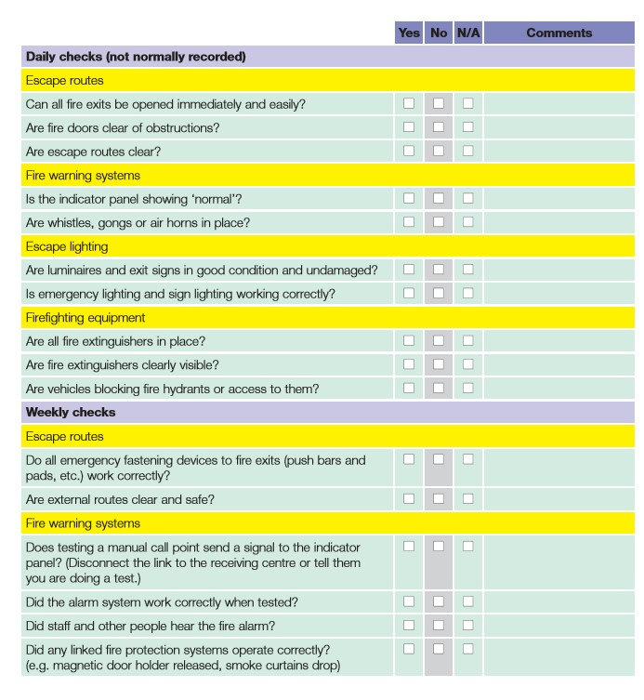

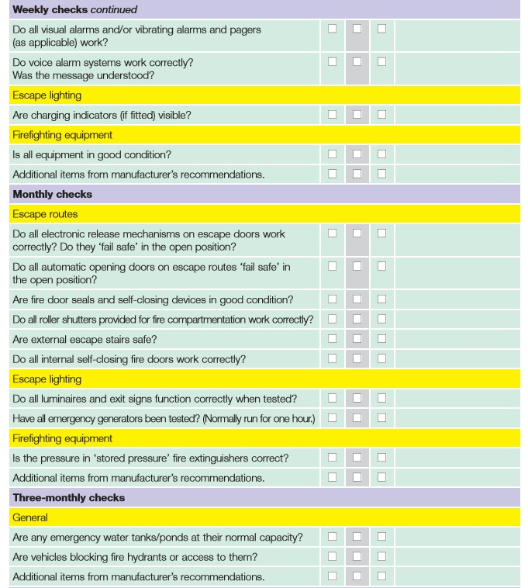

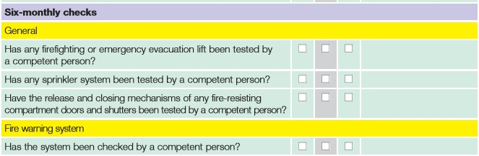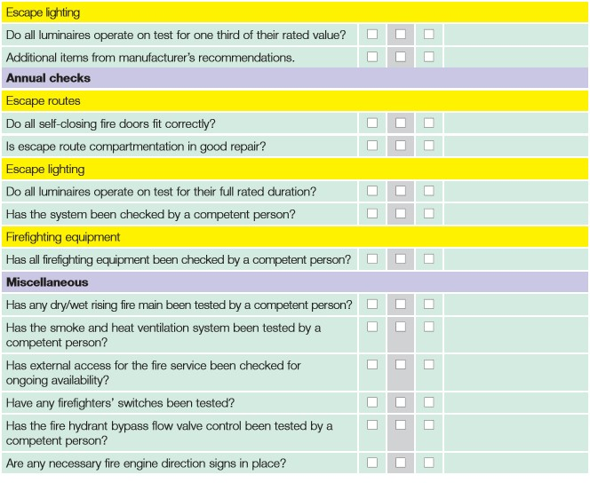

#### **Appendix 3 – Fire Safety Training Record**

|  |  |  |
| --- | --- | --- |
| **NAMED STAFF** | Fire Safety / Fire Warden / Fire  Marshal  To assist evacuation and trained in appropriate use of fire extinguishers and EVAC Chair. Level 2 Award in Fire Safety qualification has been designed for anyone who has a specific responsibility for fire safety in the workplace, such as designated fire wardens/fire marshals. **Valid for 3 years** | Level 2 Award in Fire Safety  (RQF) date of award  **Valid for 3 years** |
| Sarah Hughes | 05/09/2018 | Oct-21 |
| Mark Woods | 05/09/2018 | Jun-22 |
| Karen Nixon | 05/09/2018 | Jun-22 |
| Charlotte Murray | 05/09/2018 | Oct-21 |
| Andrew Noakes | 05/09/2018 | Oct-21 |
| John Pattison | 05/09/2018 | Oct-21 |
| Helyn Bulman | 05/09/2018 | Oct-21 |
| Sarah Galvayne | 05/09/2018 | Oct-21 |
| Lucy Arbon | 05/09/2018 | Oct-21 |
| Lauren Taylor | 08/01/2019 |  |
| Rebecca Oates | 08/01/2019 | Jun-22 |
| Jo Harrison |  | Jun-22 |
| Dom Hall |  | Jun-22 |
| Tom Sunderland |  | Jun-22 |
| Will Postlethwaite | 08/01/2019 |  |
| Sarah Richardson | 08/01/2019 |  |
| Pieter Vermaas | 08/01/2019 |  |
| Liam Clark | 08/01/2019 |  |

Staff Members no longer with

UTC

#### **Appendix 4 – Fire Safety Management Structure and Roles**

|  |  |
| --- | --- |
| **Responsible Person(s)** | |
| **The Responsible Person will direct evacuation procedures in the event of the alarm being raised and ONLY the Responsible Person will decide when it is safe to re-enter the building and inform the Facilities Team to switch off the alarm.** | |
| **Responsible Person: Sarah Galvayne (Health & Safety Lead +Science Technician)**  **If off site: Sarah Hughes (Business Liaison Manager)**  **If off site: Dan Sydes (Principal)** | |
| **Designated – Responsible Person** | **Dan Sydes (Principal)**  **Sarah Galvayne (H&S Co-ordinator/Science Technician)** |
| **Responsible Person – Out of Hours** | **Facilities Management Contracted Site Manager – Jack Cook** |
| **The Designated Person(s) will be in contact by radio to check the effectiveness and safety of the overall evacuation.** | **It is the responsibility of all persons above, named as cover for absent staff, to be aware of when the person they are covering is on / off site.** |
| **Protection Officer**    **PEEP Coordinator** | **Jack Cook**    **Helyn Bulman** |
| **Register Coordinator(s)** | **Rebecca Oates / Hattie Winnan** |

|  |  |  |
| --- | --- | --- |
|  | **Fire Marshall** | **Fire Marshall Backup** |
| **NORTH FLOOR 0** | Jen Lorimer **®** | Charlotte Murray |
| **SOUTH FLOOR 0** | John Pattison | Jo Harrison **®** |
|  |  |  |
| **NORTH FLOOR 1** | Charlotte Murray | **®**  Sarah Hughes |
| **SOUTH FLOOR 1** | Jo Harrison **®** | Charlotte Murray |
|  |  |  |
| **NORTH FLOOR 2** | Sarah Hughes **®** | Lucy Arbon |
| **SOUTH FLOOR 2** | Lucy Arbon | Andrew Noakes |
|  |  |  |
| **NORTH FLOOR 3** | Andrew Noakes | Tom Sunderland |
| **SOUTH FLOOR 3** | Dom Hall | Tom Sunderland |
|  |  |  |
| **NORTH FLOOR 4** | Mark Woods **®** | Andrew Noakes |
|  |  |  |
| **MUGA / ROOF – SOUTH FLOOR 4** | H&F staff or duty staff – otherwise locked at all times | H&F staff or duty staff – otherwise locked at all times |
|  |  |  |
| **MAIN OFFICE / RECEPTION / BUSINESS PARTNERS LOUNGE** | Rebecca Oates | Charlotte Murray |
|  |  |  |
| **OUTSIDE YARD** | Duty Staff | Duty Staff |
|  |  |  |
| **PLANT ROOM** | Locked at all times | If open Jack Cook |
|  |  |  |
| **LEASED SPACES** | Responsibility will be assigned to their staff to sweep their rooms |  |
|  |  |  |
| **CATERING KITCHENS** | Catering staff | Leanne Golightly |
| **Contact Numbers** |  |  |
| **Facilities Manager**  **Principal**  **Health &Safety Manager**  **Business Liaison Manager** | Jack Cook -07392285753  Dan Sydes – 07709632242  Sarah Galvayne - 07903727417  Sarah Hughes - 07825776848 |  |
|  |  |  |
|  |  |  |

|  |
| --- |
| **Appendix 5 Gas Cut Off Valves and Electrical Isolation Board Plans** |
| **Appendix 6 Break Glass Call Points and Emergency Refuges Points** |
| **Appendix 7 Emergency Vehicle Access Routes Around**  **Exterior Premises** |
| **Appendix 8 Types and Location of Fire Fighting Equipment and Emergency Signage** |
| **Appendix 9 Types and Location of Emergency Lighting** |

**See contractor plans for Appendix 5 to 9 – format too large to insert See below for appendix 10.**

|  |
| --- |
| **Appendix 10** |

**Fire Assembly Points**

Fire Assembly signage is mounted outside with the assembly point ***number .***

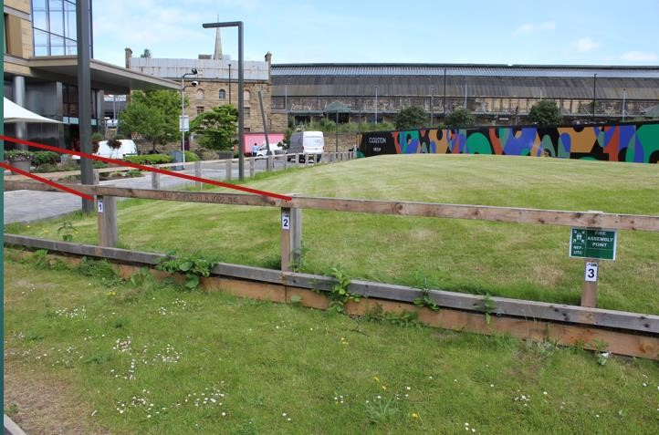

Please see below for tutor group and assembly point numbers:-

**Assembly Point 1: YR 10 - EINSTEIN**

**Assembly Point 2: YR 10 - JACKSON**

**Assembly Point 3: YR10 - MAXWELL**

**Assembly Point 4: YR10 - NEWTON**

**Assembly Point 5: YR10 - PASTEUR**

**Assembly Point 6: YR11 - BLACKBURN**

**Assembly Point 7: YR11 - FRANKLIN**

**Assembly Point 8: YR11 - RUBIN**

**Assembly Point 9: YR12 - DALTON**

**Assembly Point 10: YR12 - YOUNG**

Any staff not allocated to a tutor group is assigned to an assembly point in order to help with efficient management and roll call of students during the evacuation process.

Please see below for allocations: -

|  |  |
| --- | --- |
| Staff Member | Allocated Assembly point |
| Jen Lorimer | 1  2  3  4  3  4  5 |
| Jade |
| Helyn Bulman |
| John Pattison |
| Lucy Arbon |
| Sarah Hughes |
| Jemima Gower |

Kitchen staff and any visitors will be registered behind the bollards in front of the UTC building**.** Other visiting student, or trips will be taken as a register on the other grassed area in front of the brick wall which has an assembly point poster.