Revision Guide for Students and Parents/Carers

6th Form

Contents
Exam Period Tips: Dealing with Stress
Exam Period Tips: Eating Well
Exam Period Tips: Sleeping Properly
Planning your Time to Revise
Great Revision Techniques
Handy Revision Resources

Exam Period Tips
Dealing with Stress
Everyone will get stressed throughout the exam period and it can make you feel lots of different things:
- Tired and/or deflated
- Angry or irritable
- Under pressure
- Confused
- Worried or anxious that you won’t do well in exams
Help is at hand on how to cope with these tips and suggestions…
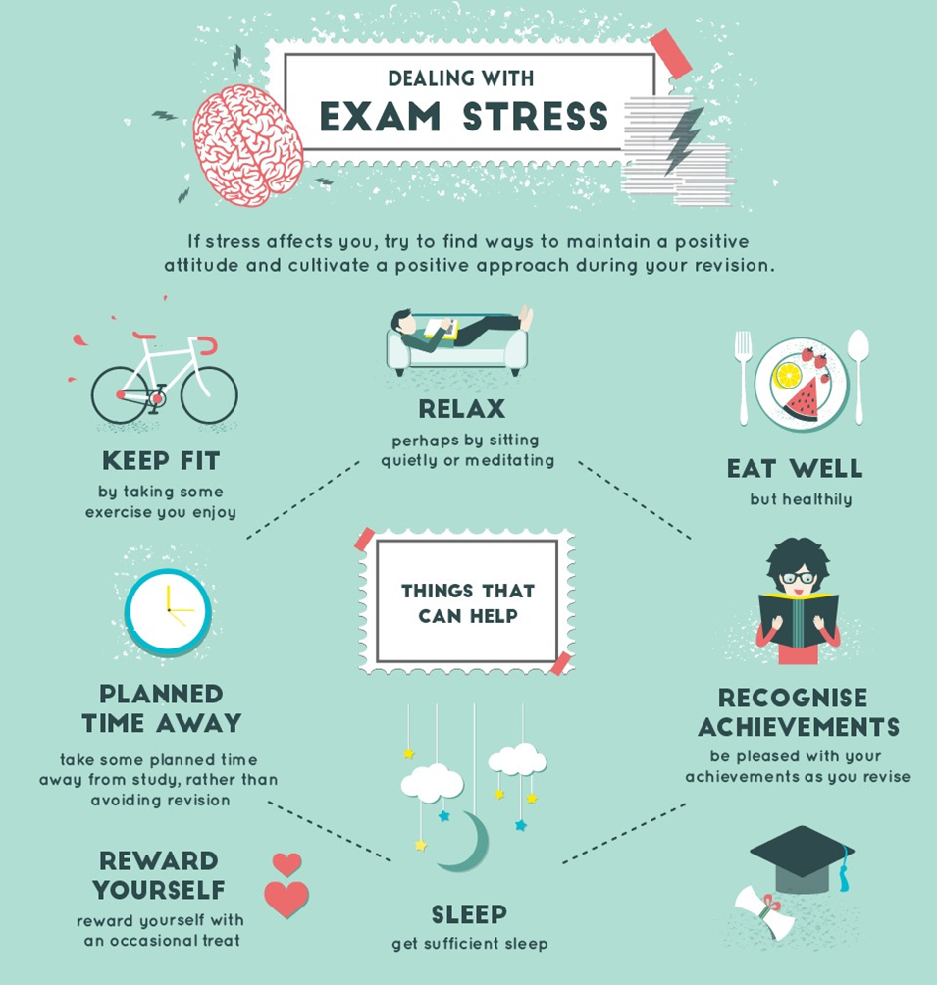
For more help on how to deal with stress, be sure to speak to your Tutor.
Looking after yourself

Eating well
The benefits of a healthy and balanced diet go beyond physical positives. They can help you stay energised throughout the exam season.
Each morning at North East Futures UTC, breakfast will be served to ensure you are ready and raring for that day’s exams.
Your performances throughout your A-levels could be damaged by sugary drinks and unhealthy snacks. Ditch energy drinks and anything else that is high in fat, sugar and caffeine.
For healthy alternatives, take note of The Eatwell Plate below…
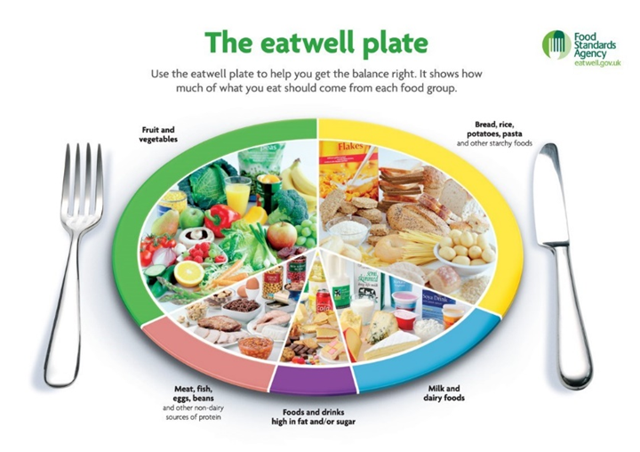

For more information, check out the NHS website:
https://www.nhs.uk/live-well/eat-well/healthy-eating-for-teens/

Sleeping Properly
8 hours is the recommended amount of sleep everyone should
have each night.

Getting enough sleep will help you stay focused during revisions
sessions and can boost your mental wellbeing.

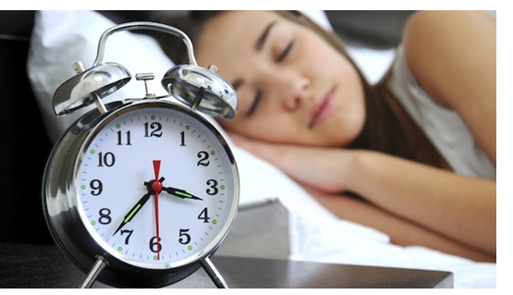
In order to get enough sleep at night, focus on your habits now and make sure you don’t look at a screen or mobile device for at least an hour before you plan on falling asleep.
Ensure your room is quiet and dark enough and at a comfortable temperature for you to sleep through the night.
Don’t eat anything sugary or caffeinated in the hours before going to bed.

Planning Time to Revise

Creating your Revision Timetable

Revision may start off as a horrible chore, but the more you do it, the more confident you’ll become.
But before you dive into the books, it’s important to take your time and plan when you are going to focus on each topic. It’s crucial to create a revision timetable, as it’s a simple but effective tool to have. As well as ensuring your revision is balanced between subjects and specific topics, you can also plan in well-deserved breaks and some time for yourself.

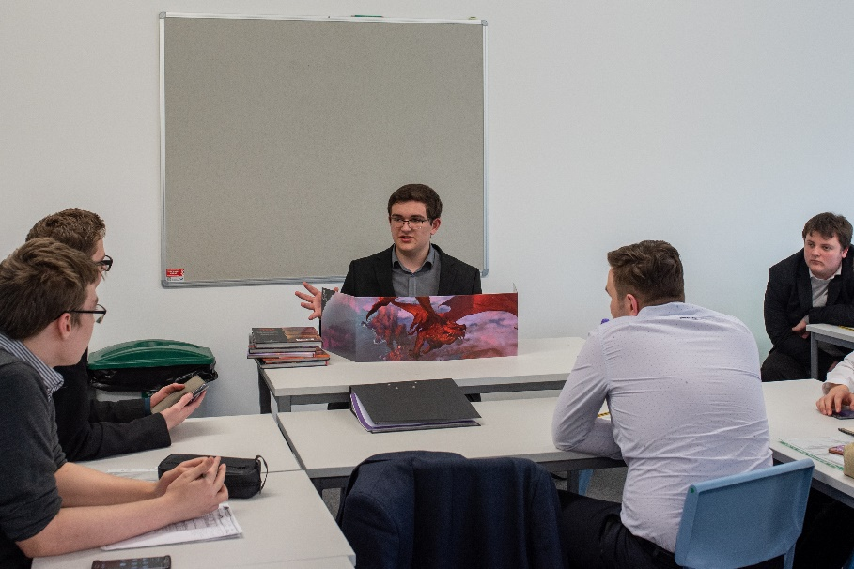
Please find an example of a Revision Timetable you can use on the next page.

For help with planning your Revision Timetable, please speak to your Tutor.

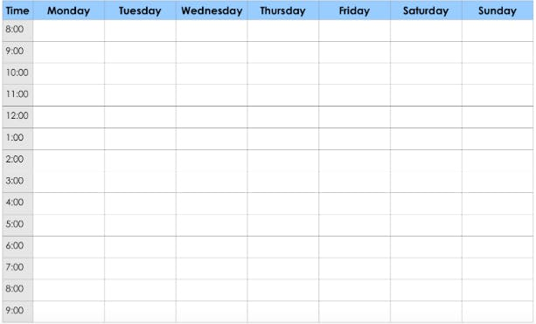
Things to consider

Check out our list on how you can make your revision timetable
work best for you:

- When planning your revision timetable, a bit of downtime on your phone or Playstation may be good for you, but too much will do you no favours.
As well as taking you away from your studies, too much time on social media or games can have detrimental effects on your sleep pattern and mental wellbeing – be tough on yourself regarding how much time you spend on electronic devices.

- Plan to study the toughest subjects as soon as possible. Not only will it bring up any areas of improvement for you to work on, it’ll have more time to become embedded into your mind.

- Plan wisely, so you’re not just revising one subject or topic, especially if they are the ones you are already most comfortable with.

- When planning time away from your resources, make sure you take it. Too much cramming will cause you to burn-out.

- Share your Revision Plan with friends and family, so everyone can support and encourage you…

- …but, do not worry if your friends have organised themselves differently or would like to revise on their own. Everyone has an individual way of taking on and remembering information. Just do what is right for you!

Great Revision Techniques

Everyone revises in their own way, but it’s good to try new and effective techniques. While reading or watching something on the topic may work for some, we wanted to share some other fresh and innovative methods that’ll help you keep key information in mind on the run-up to your exams…

Mind Maps Condensing your knowledge
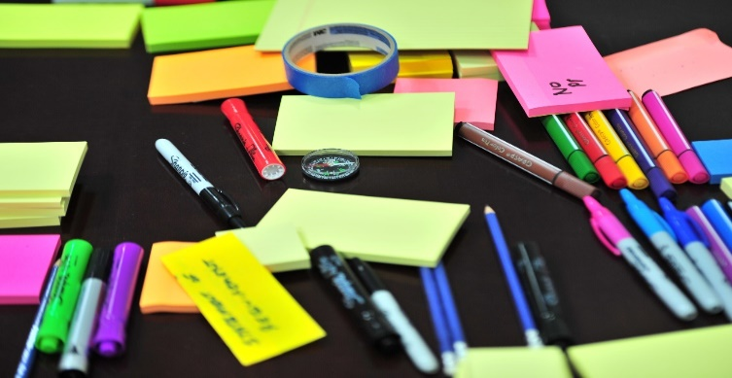

Take information from revision guides, exercise books, worksheets and YouTube.
Link related information to each other, making associations stronger in your mind.
Make it as detailed and colourful as possible – don’t skim the surface of your understanding.
Design it for someone who knows nothing about the topic, so you know you’ll be getting key information.
Take notes from YouTube videos, exercise books, worksheets and revision guides.
Highlight the key pieces of information.
Rewrite it in bullet-points, making it easy to digest and remember.
Carry them with you and read them on the bus, in between lessons or when you’d usually be on your phone.

Revising with Friends Look-cover-write-check!

Choose something you have trouble remembering.
Study the relevant information before covering it with your hand.
Write down as much as you can remember.
Check to see if the information is correct.
Pick a place that’s calm and quiet and where you’ll get lots of work done.
Take it in turns to quiz each other on specific topics and take the nerves out of exams.
Try and teach your friend something that they need to develop.
• Support each other with revision techniques
and take the fear and nerves out of exams

Handy Revision Resources
As well as your teachers and exercise books, you have a whole host of great resources to revise from, right at your fingertips.
Have a look at these ones and work them into your Revision timetable…

Past Papers
Go onto the AQA website (www.aqa.co.uk) and find past papers to help strengthen any areas of development.

YouTube
Think of how improvements can be made in specific subjects and find YouTube videos and Exam Walkthroughs to help develop your understanding.

Revision Guides
Revision Guides are available for purchasing online (Amazon, CGP) – just ask your subject teacher for their advice on the best one to purchase.
Should there be any affordability issues with purchasing revision books please contact us: office@nefuturesutc.co.uk

