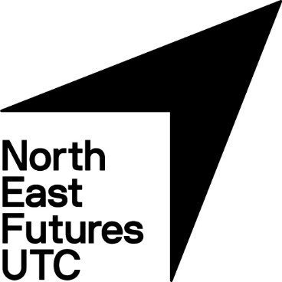

Revision Guide for Students and Parents/Carers

Year 10 and 11

Contents
Exam Period Tips: Dealing with Stress
Exam Period Tips: Eating Well
Exam Period Tips: Sleeping Properly
Planning your Time to Revise
Great Revision Techniques
Handy Revision Resources
Subject-specific Revision Guidance

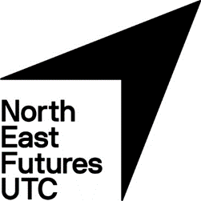
Exam Period Tips
Dealing with Stress
Everyone will get stressed throughout the exam period and it can make you feel lots of different things:
- Tired and/or deflated
- Angry or irritable
- Under pressure
- Confused
- Worried or anxious that you won’t do well in exams
Help is at hand on how to cope with these tips and suggestions…
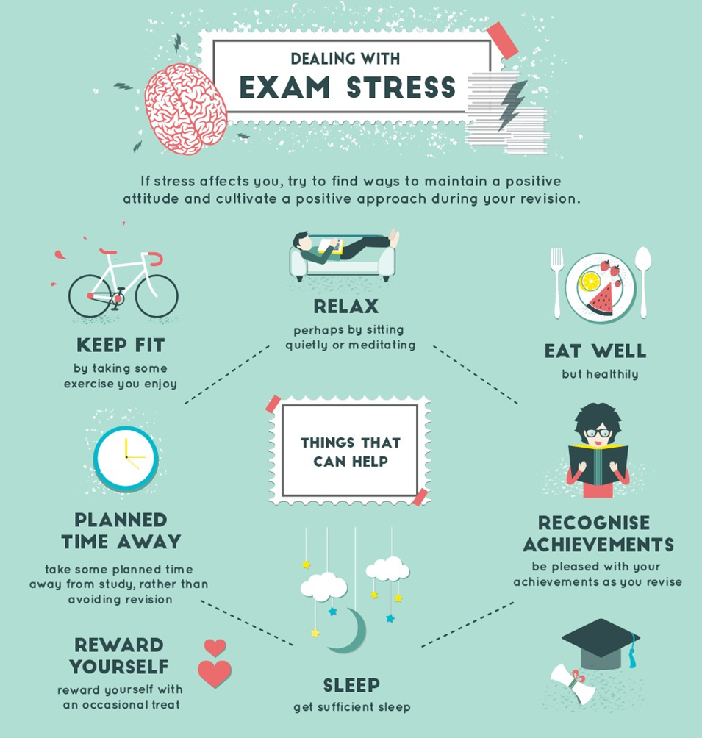
For more help on how to deal with stress, be sure to speak to your Tutor.
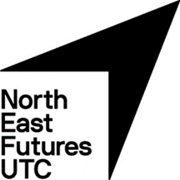
Looking after yourself

Eating well
The benefits of a healthy and balanced diet go beyond physical positives. They can help you stay energised throughout the exam season.
Each morning at North East Futures UTC, breakfast will be served to ensure you are ready and raring for that day’s exams.
Your performances throughout your GCSEs could be damaged by sugary drinks and unhealthy snacks. Ditch energy drinks and anything else that is high in fat, sugar and caffeine.
For healthy alternatives, take note of The Eatwell Plate below…
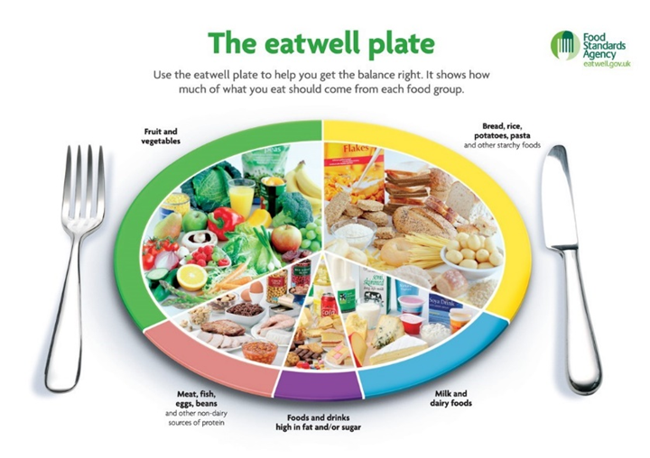

For more information, check out the NHS website:
https://www.nhs.uk/live-well/eat-well/healthy-eating-for-teens/

Sleeping Properly
8 hours is the recommended amount of sleep everyone should
have each night.

Getting enough sleep will help you stay focused during revisions
sessions and can boost your mental wellbeing.

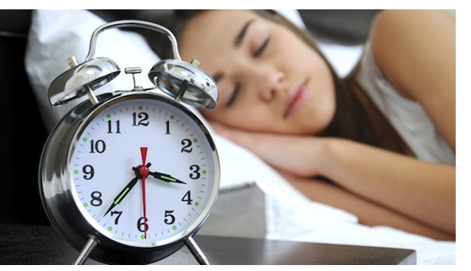
In order to get enough sleep at night, focus on your habits now and make sure you don’t look at a screen or mobile device for at least an hour before you plan on falling asleep.
Ensure your room is quiet and dark enough and at a comfortable temperature for you to sleep through the night.
Don’t eat anything sugary or caffeinated in the hours before going to bed.

Planning Time to Revise

Creating your Revision Timetable

Revision may start off as a horrible chore, but the more you do it, the more confident you’ll become.
But before you dive into the books, it’s important to take your time and plan when you are going to focus on each topic. It’s crucial to create a revision timetable, as it’s a simple but effective tool to have. As well as ensuring your revision is balanced between subjects and specific topics, you can also plan in well-deserved breaks and some time for yourself.

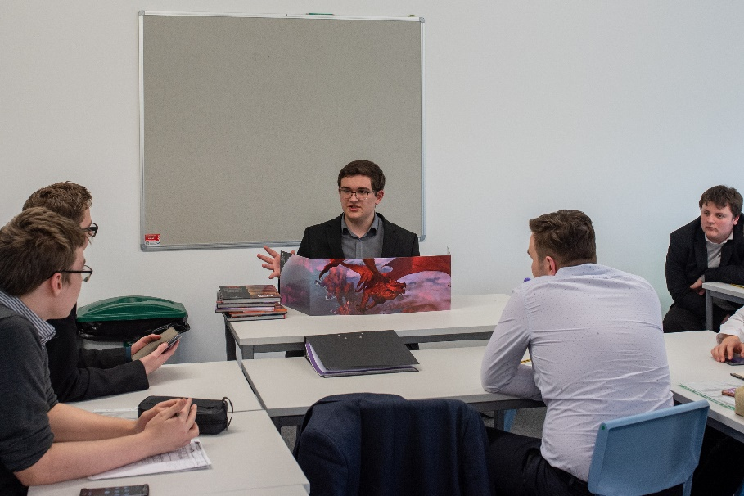
Please find an example of a Revision Timetable you can use on the next page.

For help with planning your Revision Timetable, please speak to your Tutor.

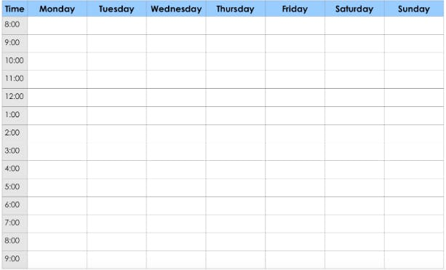
Things to consider

Check out our list on how you can make your revision timetable
work best for you:

- When planning your revision timetable, a bit of downtime on your phone or Playstation may be good for you, but too much will do you no favours.
As well as taking you away from your studies, too much time on social media or games can have detrimental effects on your sleep pattern and mental wellbeing – be tough on yourself regarding how much time you spend on electronic devices.

- Plan to study the toughest subjects as soon as possible. Not only will it bring up any areas of improvement for you to work on, it’ll have more time to become embedded into your mind.

- Plan wisely, so you’re not just revising one subject or topic, especially if they are the ones you are already most comfortable with.

- When planning time away from your resources, make sure you take it. Too much cramming will cause you to burn-out.

- Share your Revision Plan with friends and family, so everyone can support and encourage you…

- …but, do not worry if your friends have organised themselves differently or would like to revise on their own. Everyone has an individual way of taking on and remembering information. Just do what is right for you!

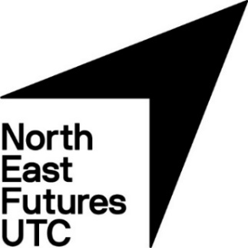
Great Revision Techniques

Everyone revises in their own way, but it’s good to try new and effective techniques. While reading or watching something on the topic may work for some, we wanted to share some other fresh and innovative methods that’ll help you keep key information in mind on the run-up to your exams…

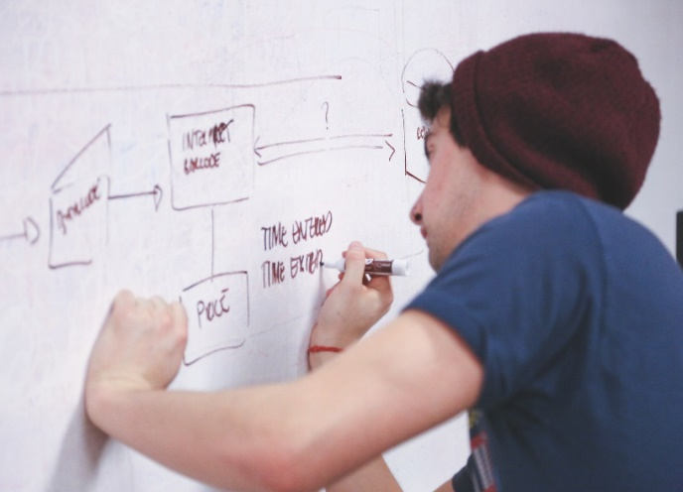
Mind Maps Condensing your knowledge
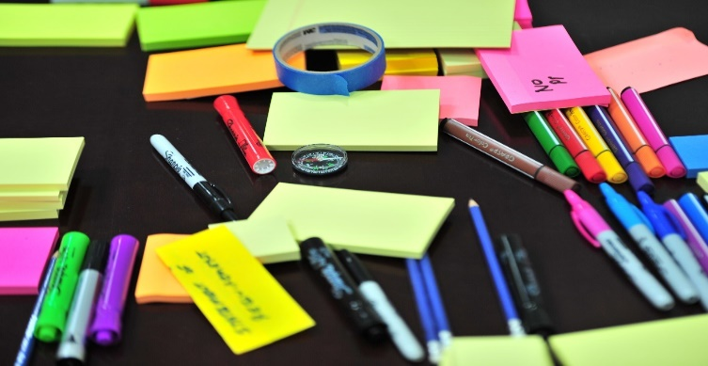

Take information from revision guides, exercise books, worksheets and YouTube.
Link related information to each other, making associations stronger in your mind.
Make it as detailed and colourful as possible – don’t skim the surface of your understanding.
Design it for someone who knows nothing about the topic, so you know you’ll be getting key information.
Take notes from YouTube videos, exercise books, worksheets and revision guides.
Highlight the key pieces of information.
Rewrite it in bullet-points, making it easy to digest and remember.
Carry them with you and read them on the bus, in between lessons or when you’d usually be on your phone.

Revising with Friends Look-cover-write-check!

Choose something you have trouble remembering.
Study the relevant information before covering it with your hand.
Write down as much as you can remember.
Check to see if the information is correct.
Pick a place that’s calm and quiet and where you’ll get lots of work done.
Take it in turns to quiz each other on specific topics and take the nerves out of exams.
Try and teach your friend something that they need to develop.
• Support each other with revision techniques
and take the fear and nerves out of exams

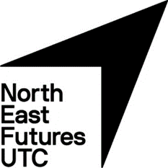
Handy Revision Resources
As well as your teachers and exercise books, you have a whole host of great resources to revise from, right at your fingertips.
Have a look at these ones and work them into your Revision timetable…

Past Papers
Go onto the AQA website (www.aqa.co.uk) and find past papers to help strengthen any areas of development.

YouTube
Think of how improvements can be made in specific subjects and find YouTube videos and Exam Walkthroughs to help develop your understanding.
Maths English Science
Raw Maths Mr Bruff Free Science Lessons
Hegarty Maths Stacey Reay

Revision Guides
Revision Guides are available for purchasing online (Amazon, CGP) – just ask your subject teacher for their advice on the best one to purchase.
Should there be any affordability issues with purchasing revision books please contact us: office@nefuturesutc.co.uk

Useful websites
There are loads of great websites to help you through your exams, but Bitesize (www.bbc.co.uk/bitesize) is generally regarded as the best.
Full of quizzes, exam-style questions and some example answers, Bitesize is always worth looking at when you’re stuck for resources on a particular subject.
If there was a topic you were struggling with, please approach your teacher and ask them to share their lesson resources on the Student Portal.

Subject specific help with revision

GCSE English Language and Literature

Use the materials in SharePoint that have been carefully curated for you along with the 200 revision tasks that you have.
Websites that are helpful:
- www.senecalearning.com Complete the courses assigned to your class, aiming for 100% on this responsive platform. Pay particular attention to the quotations courses for the Literature texts.
- Mr Bruff – YouTube – Lang and Lit - https://www.youtube.com/channel/UCM2vdqz7e4HAuzhpFuRY8w
- GCSEEnglishPod – podcasts and resources (all relevant material has been downloaded into SharePoint for you)

Apps that can be purchased for their smart phones or tablets.
- Seneca learning - Literature
- Lit Notes

Any work students can be doing at home.
- Tasks and questions in the CGP revision guides you have been provided with – Language and Literature – focus on the questions you know you’re struggling with.
- Buy and use the Complete revision and practice revision guides – complete the suggested tasks. Focus on the areas you know you’re weak in.
- Re-read Literature texts – most available online for free. Read examples of short narratives, articles, blogs, opinion writing etc. How do they begin? What do they do differently? How do they engage the reader?
- theshortstory.org.uk or https://www.bbc.co.uk/programmes/ articles/5f5dJgGQl5J3xmZhR0WsMdT/student-reports
- Create cue cards of key quotes for Literature or things to remember for each Language question. Look/write/cover/check. Ask a friend or family member to test you. Make a note of what you get wrong and repeat.
- Create a timeline of events/key points in all of the texts, including the poems, attaching quotations.
- Quotation explosions – choose a quotation and annotate with everything you can hunk of from the text which links.
- 5 minute essay plans – choose a key theme, construct a question (how does the writer present ____ in _____) and plan out your response, including AO1, AO2 and AO3, remembering to link to various places in the text for each AO1 point made.
- Create your own quiz cards at www.quizlet.com
- Revise your key Tier 2 and Tier 3 vocabulary, ensuring that you know what each word means and link it to your texts.

What materials they have that they can work on:
- The 200 revision tasks sheet (copy in SharePoint)
- Revision notes and activities in SharePoint
- Exercise books with copious notes made
- Seneca courses assigned on the Seneca Learning website

Maths

Alongside class resources all GCSE students could be revising using these recommended revision guides and workbooks.
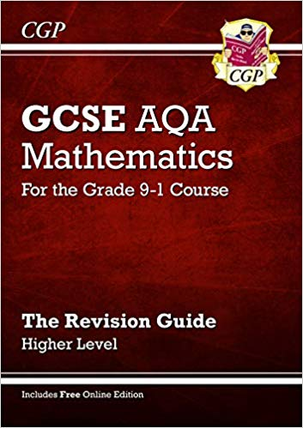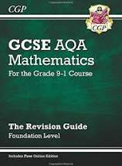
We recommend you study and complete past papers – but don’t just do the questions you can do, you have to use revision guides/websites/ friends/teachers to help you with the questions you find hard.

What materials they have that they can work on:
- Seneca courses assigned on the Seneca Learning website
- MyMaths courses assigned on the MyMaths Learning website
- AQA Website: https://allaboutmaths.aqa.org.uk/newspec8300
- Maths Made Easy Website: https://mathsmadeeasy.co.uk/gcse-maths-revision/
- Create your own Maths Quiz with Quizlet: https://quizlet.com/en-gb/content/gcse-maths
- Raw Maths (YouTube): https://www.youtube.com/channel/UCfXfXV5hOkRpXP28EBjtt_A
- Hegarty Maths (YouTube): https://www.youtube.com/results?search_query=hegarty+maths
- GCSEPod: https://www.gcsepod.com/

Biology, Chemistry, Physics

Alongside class resources all GCSE students could be revising using these recommended revision guides and workbooks.
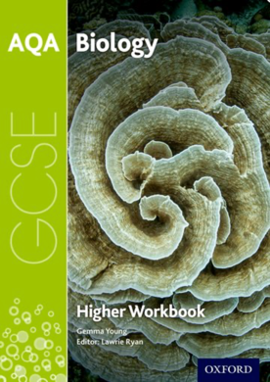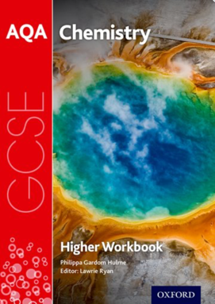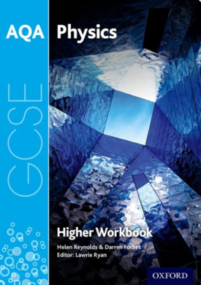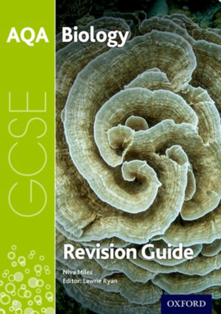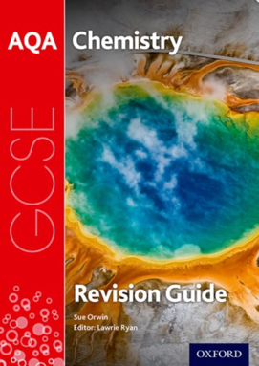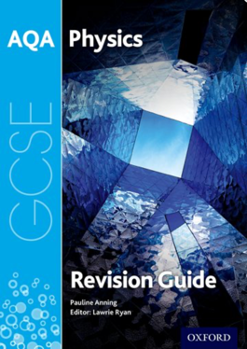
These resources have been carefully selected to match the materials students are used to using in their lessons and independent learning time (ILT). Students would not need access to the internet to revise as the content in the workbooks mirrors the revision guides.

If students are looking for additional revision videos to revise, we would recommend one website:
https://www.freesciencelessons.co.uk
There are many other online organisations available for the GCSE sciences, including those that charge a subscription free. However, we feel that this website is the best. The required practical videos will be particularly useful now 15% of the questions will assess the required practicals.
There are two examination papers in each of the three science subjects. We would recommend that students continue to revise previous content covered to prepare for their mock examinations this half term as well as new content currently being delivered. Students should revisit topics on a regular basis as we progress towards final exams in the summer term.
A reminder that all students at North East Futures UTC sit separate GCSEs in Biology, Chemistry and Physics. Commonly known as Triple Science where students receive three GCSEs as opposed to only two. Only 27% of students in England are given this opportunity. This does mean that our students have a lot of science content to revise so students should start revision immediately. There is no coursework.

Computer Science

Alongside class resources all GCSE students could be revising using these recommended revision guides and workbooks.
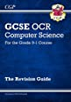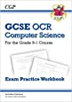
These resources have been carefully selected to match the materials students are used to using in their lessons and independent learning time (ILT). Along with these resources all students have access to lesson materials on Teams, topic tests and past exam questions specifically focussed on the OCR syllabus.

If students are looking for additional revision videos to revise, we would recommend:
https://student.craigndave.org/gcse-ocr-j277-computer-science-videos

There are many other online organisations available for the GCSE Computer Science, including those that charge a subscription free. Free ones we suggest include: https://www.computerscience.gcse.guru/ and
https://getrevising.co.uk/resources/level/gcse/subjects/computing

There are two examination papers at the end of GCSE. We would recommend that students continue to revise Paper 1 and Paper 2 to prepare for their mock and final examinations. Students will spend some time in school preparing for examination style questions and topics which are more technical. They should also be completing ILT tasks from the materials provided by teachers, along with their own revision at home. Students will sit 2 examinations in the summer. Each examination paper is worth 50% of their final grade so equal revision time should be spent on each paper. Due to this being a lot of content students should start revision immediately if they have not yet done so.

Business and Enterprise
The teacher will provide revision materials including:
- Materials on teams
- Exam style questions
These should be used to revise.
Additional sites which may be helpful:
- https://www.gcsepod.com/
- https://www.bbc.co.uk/bitesize/examspecs/zy3ptyc

Geography
The teacher will provide revision materials including:
- A booklet of case study materials to be memorised and used for revision
- A booklet of exam style questions
- A knowledge organiser
- Assignments on seneca
- Materials on teams
These should be used to revise. 1 and 2 will be used in class. 3, 4 and 5 should be used at home and in ILT.
Additional sites which may be helpful:
- https://www.gcsepod.com/
- https://www.bbc.co.uk/bitesize/examspecs/zy3ptyc

History
The four topics we study are:
- Paper 1(A): Germany 1890–1945: Democracy and dictatorship
- Paper 1(B): Conflict and tension between East and West, 1945–1972
- Paper 2(A): Britain: Migration, empires and the people: c790 to the present day
- Paper 2(B): Elizabethan England, c1066–c1100
Revision help
- CGP Guides – all students are recommended to purchase these excellent revision guides for the Germany and East/West Topics. There is also a guide for the Norman topic.
- Seneca Learning – both topics covered in mocks are open to all students. The remaining two will be opened after mocks.
- Create a timeline of the main events in a topic – this is hugely helpful as some of the questions worth the most marks are about events between two specific dates (any examples from outside of these dates would not be credited with marks)
- Flash cards – will help you remember key words and events. Keep them in date order for extra benefit. Give them to a friend or family member to test you.
- BBC Bitesize – has videos, short topic explainers and short knowledge tests. Make sure you get the correct section: GCSE AQA History.

Creative iMedia
Alongside lesson resources which have been added to Microsoft Teams, all Creative iMedia students should be revising using GCSE Pod and the ZigZag ‘Topic on a Page’ worksheets. We would also recommend using “My Revision Notes: OCR Cambridge Nationals in Creative iMedia L 1 / L2
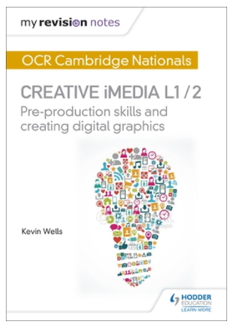
This resource has been carefully selected to match the materials students are used to using in their lessons and independent learning time (ILT).

Students sit only 1 examination in this course, but attendance during the rest of the year is vital in order to complete the 3 examined projects.
The written exam paper is worth 25% of the overall marks and the three projects make up the remaining 75%. Students are allocated a set time frame for each project and all work will be sent by school to the exam board by their given deadline.

