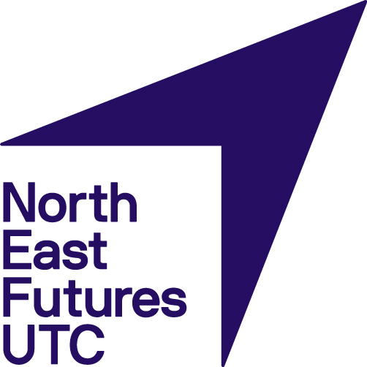

The 16 to 19 tuition fund 2021 to 2022 academic year

North East Futures UTC have signed up to access post 16 tuition funds. This funding will be spent in accordance to government guidelines which can be found on the DFE website at the following link:

https://www.gov.uk/guidance/16-to-19-funding-16-to-19-tuition-fund

North East Futures UTC will spend this money in the following ways:

- 1-2-1 tuition in circumstances where the child will benefit or needs such a bespoke curriculum that it is beneficial to have it as a 1-2-1 tuition
- Small group tuition where multiple children can benefit from the same type of tutoring, this would be in groups of no more than 4 children at a time
- Tutors will mainly focus on English and Maths and will be supporting those who did not pass these subjects
- Some tuition will be sought in vocational subjects
- The majority of tuition will be sourced through a third party provider

For further information please email Assistant Principal/ Head of Sixth Form- Liam Clark, liam.clark@nefuturesutc.co.uk.

