Admission Arrangements for 2022

North East Futures UTC has been established to support growth in IT and Healthcare Science sectors in the North East and contribute to overall regional growth.

It provides the opportunity for young people from all the communities in this region from which students can travel on public transport within in one hour, to benefit from its specialist provision.

The Board of Trustees and all the North East Futures staff are committed to a policy of equality and aim to ensure that all students, employees, job applicants, other member of the school community and visitors are treated fairly and with respect.

We aim to give equal access to the high quality educational opportunities we provide and to ensure that everyone feels that they are a valued member of the school community. We seek to create a safe and happy environment where all our students can flourish and where social and cultural diversity are celebrated.

Reviewed by: | LGB
Frequency of policy review: | Annually
Lead Sub Committee for discussion: | LGB
Last Reviewed: | 12 March 2021
Review by | Daniel Sydes
Signature | 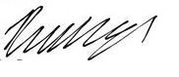
Ratified by Board of Trustees on: | 12 March 2021
Name or Trustee: | Michael Whitaker
Signature:
Next Review Date: | February 2022

1. Introduction

North East Futures UTC (the UTC) has been created to provide 14-19 education for career-minded young people in the North East who seek careers in Health and/or Technology. These are two of the fastest growing employers in the region and contribute significantly to economic growth.

North East Futures UTC is a state funded, co-educational school and sixth form situated in The Stephenson Quarter, Newcastle upon Tyne, catering for 14-19 year old students, drawn from Darlington, Durham, Gateshead, Hartlepool, Newcastle, North Tyneside, Northumberland, South Tyneside and Sunderland Local Authority areas (see Appendix 1). Admission arrangements for 2022 are set out below.

The UTC is committed to straightforward, open fair and transparent Admission arrangements. The UTC will act fully in accordance with both the School Admissions Code (as revised August 2017) and the School Admission Appeals Codes, as they apply to Academies. Both of these admissions codes will be referred to as “the codes” thereafter in this document.

The UTC seeks to admit students from across the region. Students are expected to self- select to apply to the UTC on the basis of access to their desired career pathway. Targeted marketing and recruitment activity, supported by an extensive network of Employer Partners will seek to ensure that the UTC attracts students with an interest in its specialisms.

The UTC provides school places to young people of all abilities aged between 14 and 19. It offers a combined academic and technical curriculum. The UTC will be nonselective at 14 but expects that students who apply will want to learn about and be interested in careers in Healthcare Science and Information Technology. The UTC has clear entry requirements for different pathways at 16.

2. Admission Numbers

North East Futures UTC has an admission number of 120 for entry in each of year 10 and year 12 and 30 students for entry into Year 7 in September 2022. Please note the admission of Year 7 students in September 2022 as of 1st March 2021 is awaiting approval from the Department for Education.

The UTC will accordingly admit this number of pupils if there are sufficient applications. Where fewer applicants than the published admission number for the relevant year group are received, the UTC will offer places to all those who have applied. However, to be eligible for admission into year 12, applicants must meet the minimum academic entry criteria for certain qualifications to be undertaken.
Students who are in Year 11 at the UTC who apply for a place in the 6th Form before the application deadline below will be given priority admission before offers are made to external applicants.

3. Application Process

North East Futures UTC will process applications outside the normal process of coordination. This means that you will need to make a separate application for this school.

The application form is available from the address below and can be found on the school website (http://www.nefuturesutc.co.uk/).

Applications should be sent to:

The Principal,
North East Futures UTC,
Hawthorn Square,
Forth Street,
Newcastle upon Tyne,
NE1 3AS

T: 0191 9179888
E: info@nefuturesutc.co.uk
W: http://www.nefuturesutc.co.uk/

The UTC runs a series of induction, admission and enrolment events for students who have applied for a place.

All applications should be received by the 31st January 2022.

Offers will be made to all parents/carers who have applied for a place for their child by the deadline within 1 month of the deadline passing.

Applications made after the 31st Jan 2022 will still be considered and, where available, places will be offered on a first come, first serve basis until capacity is reached.

Where applications are received after capacity is reached in any year group, applications will be added to the waiting list for places and the oversubscription criteria, as detailed below, will apply.

4. Academic entry criteria for year 12

In order to be eligible for entry or progression into year 12, applicants and our own year 11 students will normally be required to have met the following academic entry criteria to complete our Level 3 programme:

Five GCSE passes including English and Mathematics at Grade 9-4 under the GCSE grading system.

In addition to these academic entry/progression criteria, the UTC has additional academic criteria for some subjects.

The UTC may offer Level 2 pathways for students who do not reach the entry criteria for the Level 3 programme.

5. Oversubscription criteria for year 10, year 7 and year 12 applicants

When the UTC is oversubscribed, after students with an Education, Health and Care Plan naming the school have been awarded a place, priority for admission will be given to those children who meet the criteria set out below, in priority order:

Criterion 1: Children in Public Care (Looked After Children) or who have previously been looked after by an English local authority but immediately afterwards were adopted. ‘Adopted’ includes being subject to a child’s arrangements order or special guardianship order;

Criterion 2: Children living within the catchment area set out in the appendix at the end of this document prioritised in the following order

- Children with a sibling* who has been given a place at North East Futures UTC
- Children residing within the identified Local Authority areas that surround North East Futures UTC – Darlington, Durham, Gateshead, Hartlepool, Newcastle, North Tyneside, Northumberland, South Tyneside and Sunderland.

Criterion 3: Children living outside those areas identified in Criterion 2

7. Tie Break

In the event of two or more applications that cannot otherwise be separated, random allocation** will be used as a tie-break. All processes of random allocation under these arrangements will be supervised by someone independent of North East Futures UTC.

8. Late Applications

Applications received by the UTC after the identified deadline will be considered to be late applications. Late applications will be considered after those received on time. If, following consideration of all applicants the UTC is oversubscribed, parents and carers may request that their child is placed on the waiting list.

9. Admission of children outside their normal age group

Parents and carers may request that their child is admitted outside their normal age group. When such a request is made, the Local Governing Body of NE Futures UTC will make a decision on the basis of the circumstances of the case and in the best interests of the child concerned, taking into account the views of the Principal and any supporting evidence provided by the parent or carer.

The process for requesting such an admission is for the parent or carer to make a case for admission out of the normal age group. This is usually completed through a meeting with the Principal or the Admissions Team.

The parent or carer will be notified of the decision within 2 working weeks (10 school days) of the request.

If a request is refused, the child will still be considered for admission to their normal age group.

10. Waiting lists

The UTC operates a waiting list for each year group. Where in any year the UTC receives more applications for places than there are places available, a waiting list will operate until the end of the academic year. This will be maintained by North East Futures UTC and it will be open to any parent or carer to ask for his or her child’s name to be placed on the waiting list, following an unsuccessful application.

A child’s position on the waiting list will be determined solely in accordance with the oversubscription criteria given above. When places become vacant they will be allocated to children on the waiting list according to the oversubscription criteria.

11. Appeals

All applications refused a place have a right of appeal to an independent appeal panel constituted and operated in accordance with the School Admission Appeals Code.

Parents and carers have 4 working weeks (20 school days) from the date of notification that their application was unsuccessful to lodge an appeal.

Parents or carers wishing to appeal should send their appeal to the Clerk of the Appeal Panel, North East Futures UTC, Hawthorn Square, Forth street, Newcastle upon Tyne, NE1 3AS

Information on the timetable for the appeals process is published on our website at: http://www.nefuturesutc.co.uk

*Sibling

Sibling means a natural brother or sister, a half brother or sister, a legally adopted brother or sister or half-brother or sister, a step brother or sister or other child living in the same household as part of the same family who, in any of these cases, will be living at the same address at the date of their application for a place.

**Random Allocation

Random allocation will be undertaken by an independent body or person.

Appendix
The following maps show the catchment postcode areas over the 9 Local Authorities from which students may apply to North East Futures UTC:

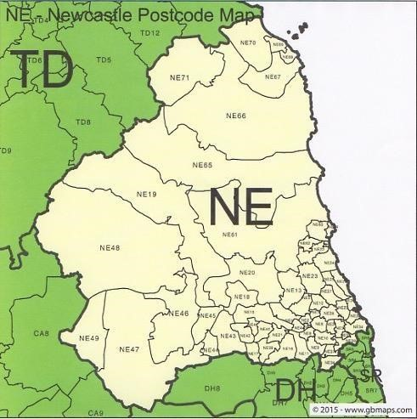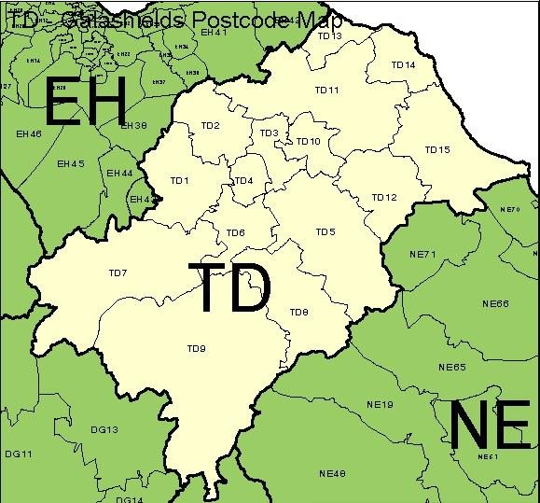
- Only TD 15

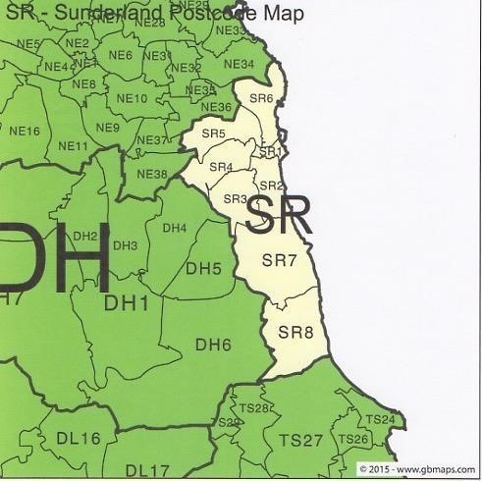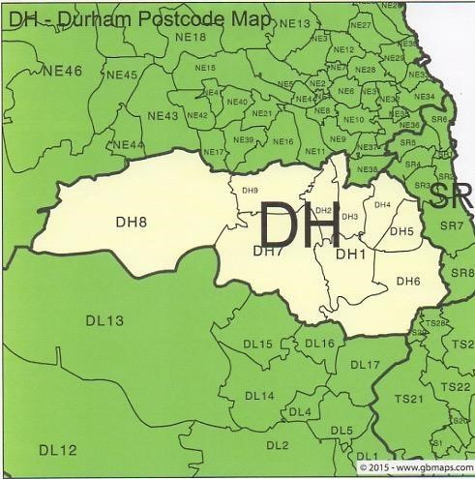

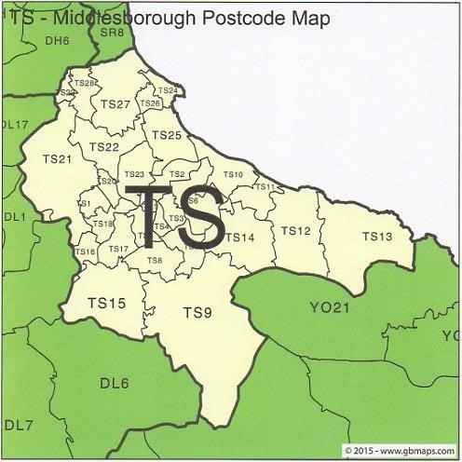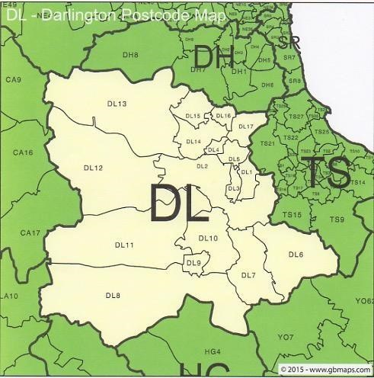
- Only TS24,TS25,TS26 and TS27

