Mathematics

Course Overview
- Exam Board – AQA
- Usual Age Range – 14-16
- Qualification – Equivalent to 1 GCSE
- Curriculum Time – Five 50 minute lessons per week in class plus additional work in Independent Learning Time
- Assessment – this curriculum is assessed via 3x 90-minute exams (2 calculator, 1 non-calculator)
- Grading – 9-1
- Full specification - https://filestore.aqa.org.uk/resources/mathematics/specifications/AQA-8300-SP-2015.PDF

Curriculum Intent
The intent of the Mathematics curriculum is to enable UTC students to become the best mathematicians they can be. We aim to do this by building up their skills base and maximising their potential in mathematics, so that when they leave school they are confident and competent to deal with any mathematical problem they face in their lives and future careers.
Our mathematics curriculum will give students the opportunity to:
- become fluent in the fundamentals of mathematics, through varied and frequent practice with increasingly complex problems over time, so that pupils develop conceptual understanding and the ability to recall and apply knowledge rapidly and accurately.
- reason mathematically by following a line of enquiry, conjecturing relationships and generalisations, and developing an argument, justification or proof using mathematical language.
- can solve problems by applying their mathematics to a variety of routine and non-routine problems with increasing sophistication, including breaking down problems into a series of simpler steps and preserving in seeking solutions.
- communicate, justify, argue and prove using mathematical vocabulary.
Students are encouraged to develop their appreciation and love of mathematics by taking part in extra curricular opportunities such as inter-school maths competitions and lectures.
Suggested next step destinations after completion include A Level Mathematics and Core Maths (Level 3 in Mathematical Studies).
Almost all future career paths will require a certain level of mathematics, be they in technology, health care or industry. Employers value the many ‘soft’ skills that mathematics builds up – such as problem solving, critical thinking and numerical awareness.

Study Tips
Students will benefit additional study using the following resources:
- GCSEPod – https://www.gcsepod.com/gcse-learning-and-revision-pods/
- GCSE Bitesize - https://www.bbc.co.uk/bitesize/subjects/z38pycw
- Seneca - https://senecalearning.com/en-GB/blog/gcse-maths-revision/
- CGP Study Guide - https://www.cgpbooks.co.uk/secondary-books/gcse/9-1-gcse-maths-student-books
- Practice Assessments and papers

GCSE Mathematics Higher
- The learning in GCSE Mathematics Higher strand is structured as follows.
- Year 10:

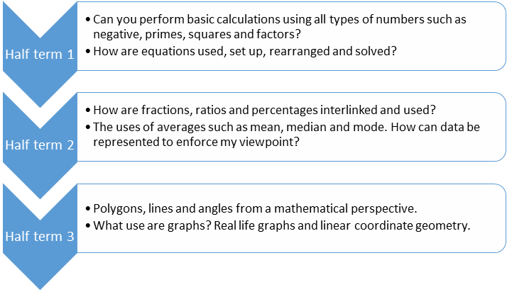
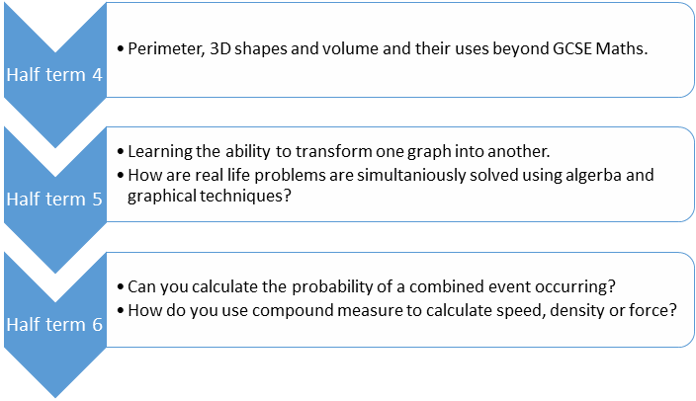

Year 11: 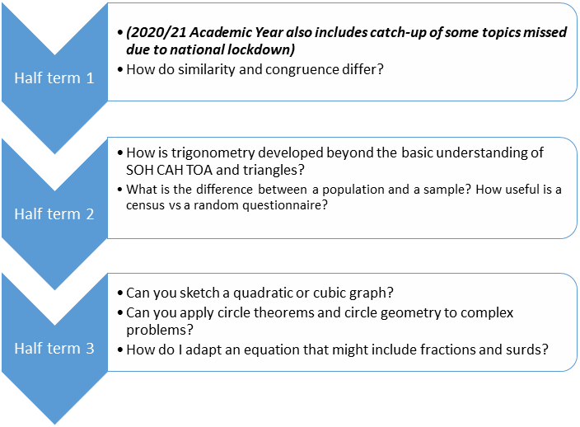

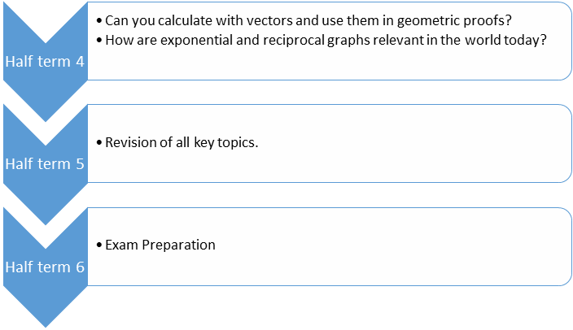

GCSE Mathematics Foundation
The learning in GCSE Mathematics Higher strand is structured as follows.
Year 10:
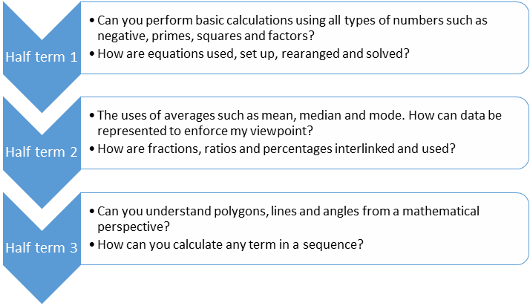

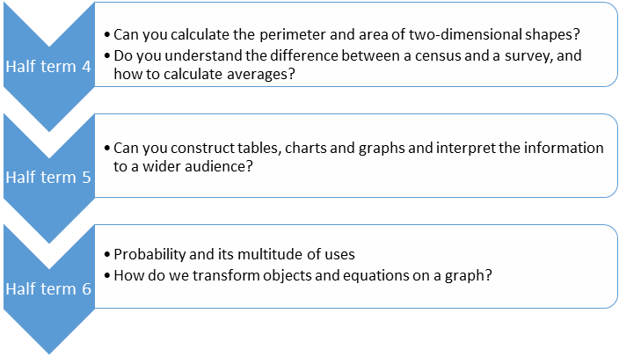

Year 11:
