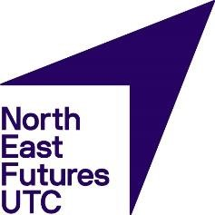
OFSTED Inspections

North East Futures UTC has been established to change the education, skills and employment paradigm in our IT and Healthcare Science sectors in the North East. It provides the opportunity for young people from all the communities in this region to benefit from its specialist provision.

Local Governors and all the North East Futures staff are committed to a policy of equality and aim to ensure that all students, employees, job applicants, other member of the school community and visitors are treated fairly and with respect.

We aim to give equal access to the high quality educational opportunities we provide and to ensure that everyone feels that they are a valued member of the school community. We seek to create a safe and happy environment where all our students can flourish and where social and cultural diversity are celebrated.

Introduction

North East Futures UTC does not currently have an OFSTED report and has not had any form of OFSTED inspection since opening in 2018.

The UTC is expecting a full Section 5 inspection in the academic year 2021-22

In the absence of a formal OFSTED report, the UTC works closely with other TCAT schools and it’s Teaching School partner Ron Dearing UTC (OFSTED Outstanding) to quality assure the curriculum and the quality of education at the UTC.

